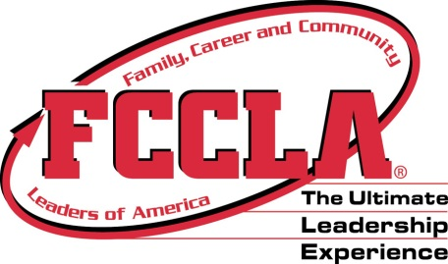
WA-FCCLA State Leadership Conference
Reservation Request Form-2
Room Assignments/Submit by Friday, February 17, 2023

Chapter Name

Type  (Sing. Dbl., Trip, Quad) | Room No. (given by hotel at time of check in) | Names | A-Adviser  S-Student | M-Male  F-Female | Date  In | Date  Out
1.
2.
3.
4.
1.
2.
3.
4.
1.
2.
3.
4.
1.
2.
3.
4.
1.
2.
3.
4..
1.
2.
3.
4.
1.
2.
3.
4.
1.
2.
3.
4.
1.
2.
3.
4.
1.
2.
3.
4.
1.
2.
3.
4.

