Washington Family, Career and Community Leaders of America

Chapter Adviser Manual

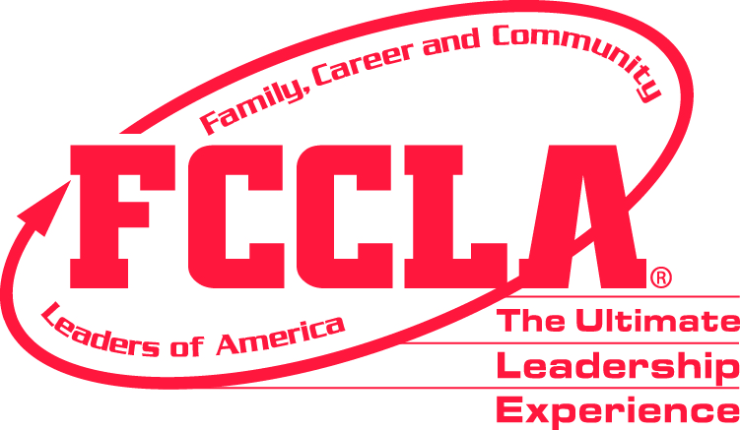

A RESOURCE GUIDE FOR FCCLA STUDENT LEADERSHIP
IMPLEMENTATION IN FAMILY AND CONSUMER SCIENCES EDUCATION

Washington Family, Career and Community Leaders of America

CHAPTER ADVISER MANUAL

Chris Reykdal
State Superintendent of Public Instruction

Michelle Spenser, Program Supervisor
Family and Consumer Sciences Education
Michelle.Spenser@k12.wa.us

Mike Oechsner
WA-FCCLA Executive Director
ExecutiveDirector@wa-fccla.org

Kathy Hahn
WA-FCCLA State Adviser
kathyhahn@wa-fccla.org

This material is available in alternative format upon request. Contact Career and Technical Education, 360/725-6243, TTY 360/664-3631. The Office of Superintendent of Public Instruction complies with all federal and state rules and regulations and does not discriminate on the basis of race, color, national origin, sex, disability, age, or marital status.

2021
TABLE OF CONTENTS

I. Introduction 3

II. Section I - State Organization 5

A. Organizational Structure 6

B. State Historical Highlights 10

C. Board of Directors 12

D. State Officer Information 13

E. Honorary Memberships 38

F. Scholarships 40

G. Bylaws 44

III. Section 2 - Local Organization 58

- Chapter Adviser’s Responsibilities 59

- Responsibilities of Chapters Attending Regional,
State, and National Meeting 62

- Integrating Family, Career and Community
Leaders of America (FCCLA) and Family and
Consumer Sciences Education (FACSE) 64

- Integrating FCCLA National Programs into FACSE 65

- Integration Planning Chart 68

- Integrating FCCLA Chapters into FACSE 69

- Why Me? 70

IV. Section 3 - National Programs & Competitive Events 71

- National Programs 72

- Power Of One 73

- Competitive Events 74
V. Section 4 - Resources 75

- “Where do I find it?” Chart 76

- People Who Can Help 77

- Chapter Accomplishment Ribbon Application 78

- Planning Process 79

- Participation Certificate 82

- Appreciation Certificate 83

- Sample Name Card 84

- Sample Introductory Brochure 85

- Step One Activity 86

- Code of Conduct 88

- Consent for Emergency Medical Care 89

VI. Section 5 - New Adviser Materials 90

- Year at a Glance 91

B. Program of Work ------------------------------------------------------- 92

C. FCCLA Program of Work Activity Quality----------------------- 95

INTRODUCTION

Welcome to the wonderful world of student leadership development through Family, Career and Community Leaders of America (FCCLA)! Every major study on student success at home, in school, in the community, and on the job indicates the importance of leadership skills. Such skills as human relations, communication, small and large group management, project planning and implementation, public speaking, problem solving, and decision making are identified as essential.

It has been said that advisers grow tenfold as they help students grow. Because the adviser is most important to the success of the FCCLA chapter, this handbook has been developed to assist advisers in their leadership role. The adviser is the stimulus, the activator, and the foundation for the success of the organization.

Why FCCLA?
Involvement in a nationally recognized program of student leadership development gives young men and women enrolled in FACSE an opportunity to develop leadership skills within the classroom, practice those skills solving real challenges at home and school, and demonstrate their success at the regional and national level among their peers. FCCLA materials are ready-made curriculum resources for advisers to teach leadership skills within their classes. These activities reinforce the use of essential learnings and are aligned with the FACSE National Standards and the SCANS skills.

Framework of the Chapter Adviser Manual
The five sections include a description of the programs, projects, and processes, which make up Washington FCCLA. Yearly changes will be updated with revised pages each fall. The manual will be posted on the Washington FCCLA Website
https://wa-fccla.org/resources/

Section 1—State Organization
Included are guidelines for state officer election and responsibilities, scholarships, honorary membership, and the bylaws, which are the governing document of the organization and define the relationship between FCCLA, the national organization, and FACSE.

Section 2—Local Organization
This section includes helpful information specifically for Washington advisers. National resources contain information applicable to all advisers and are a wealth of additional information.

Section 3— National Programs
This "one-stop shopping" overview of all programs includes information on how to obtain program books and resources. Each program lends itself for use as a method of teaching FACSE concepts and leadership skill development. Advisers will want to obtain at least one copy of each program handbook.

Section 4—Resources
Publications, forms, and people that can help the local adviser and chapter.

Section 5—New Adviser Materials
The new adviser section includes “often asked questions”, a blueprint for getting started, and information regarding resources.

We believe that FCCLA can make the difference between a traditional classroom and one that focuses on preparation of young men and women to meet the challenges of an ever-changing tomorrow.

Do not hesitate to contact the state adviser for assistance or with questions.

Kathy Hahn, Washington State FCCLA Adviser

kathyhahn@wa-fccla.org

Cell Phone: 425-530-1907

SECTION 1

STATE ORGANIZATION:

- ORGANIZATIONAL STRUCTURE
- STATE HISTORICAL HIGHLIGHTS
- BOARD OF DIRECTORS
- STATE OFFICER INFORMATION
- HONORARY MEMBERSHIP
- SCHOLARSHIPS
- BYLAWS

ORGANIZATIONAL STRUCTURE

National Level

The national organization Family, Career and Community Leaders of America, Inc. (FCCLA), office is located in Reston, Virginia. Leadership is provided by national officers, the board of directors, and the national professional staff. The leadership, through the national headquarters office, gives direction to a national public relations program, supplies national publications, recommends programs for decision-making and personal growth, and provides pre and in-service training for advisers. The National Executive Council serves the membership as the youth decision-making body. The National Board of Directors serves the membership through representation of all phases of family and consumer sciences education. The national level of FCCLA includes every member of FCCLA in all 50 states, Washington, DC, Puerto Rico, the Virgin Islands, and Guam.

National Regions Level

The national organization is divided into four regions: Central, North Atlantic, Pacific, and Southern. Washington is in the Pacific region.

State Level

The Washington Association of FCCLA consists of local chapters within the state. State officers come from the ten regions. Each region elects two state officers. These officers serve as members of the executive council. Governance of the organization occurs through a Board of Directors. The members of the Board of Directors represent Career and Technical Education (CTE), school leadership, FCCLA advisers, Family and Consumer Sciences (FCS) teachers, FCCLA State President and Vice President of Finance, and FCS-related industry. Additional adult leadership is provided by the advisory board. Members of the advisory board include advisers to the state officers, the state adviser, the state president, and the state Vice President of Finance. The FACSE supervisor at OSPI serves as chair of the advisory board.

The executive council and advisory board develop and implement a state program of work and provide leadership for state leadership conference and regional leadership meetings. They serve as an important link between the national and local levels.

Regional Level

The state association of FCCLA is divided into ten regions (see map and description on page 8-9). Each region has two state officers and their advisers. Fall and spring regional meetings and regional STAR Events are held annually.

Local Level

FCCLA chapters address preparation for those careers with recognition that workers fill multiple roles as family and community members as well as employees. The local chapters of FCCLA are made up of students who have taken or are taking a course in FACSE. The FACSE teacher serves as the adviser.
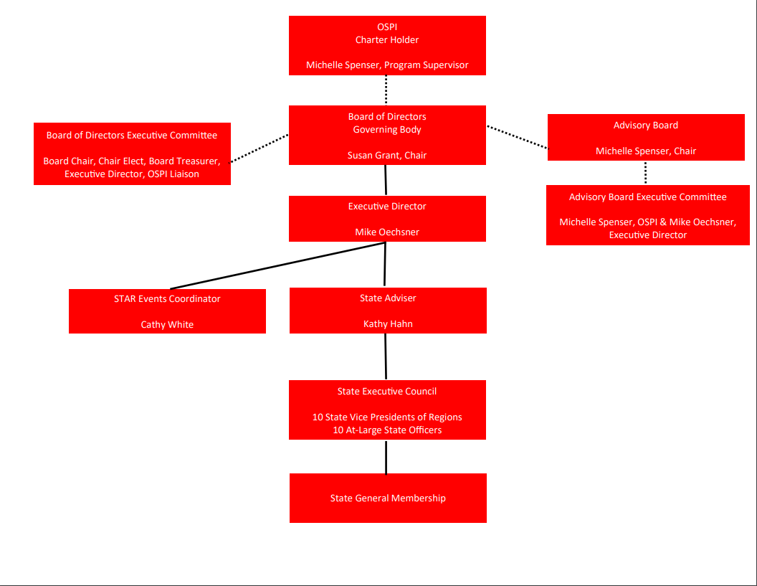
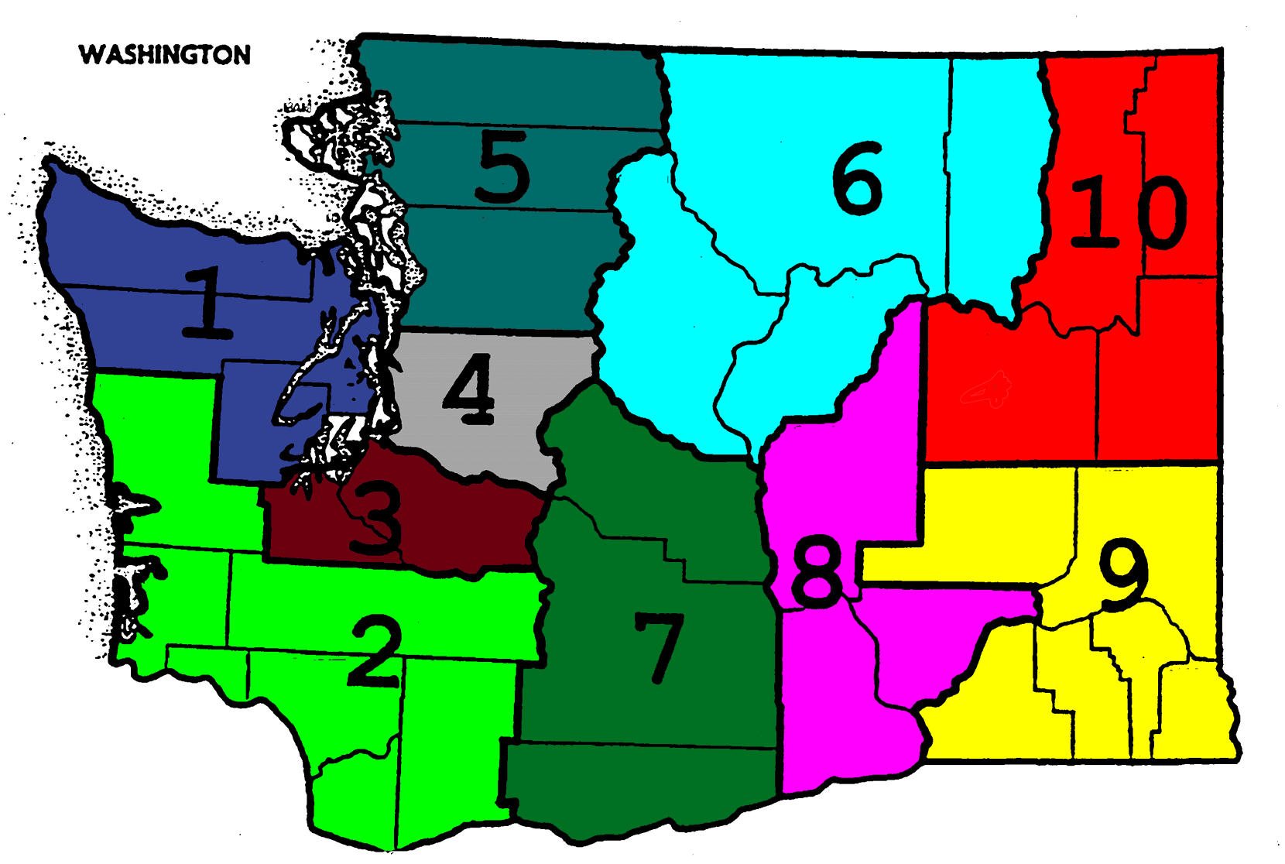

WASHINGTON FCCLA REGIONS

Regions are composed of counties and portions of counties as described below:

Region 1:

Kitsap, Clallam, Jefferson and Mason

REGION 2:

Grays Harbor, Pacific, Lewis, Wahkiakum, Cowlitz, Clark and Skamania

REGION 3:

Pierce and Thurston

REGION 4:

King

REGION 5:

Whatcom, Skagit, Snohomish, Island and San Juan

REGION 6:

Okanogan, Douglas, Chelan and Ferry

Grand Coulee Dam, Quincey, Republic and Curlew School Districts

REGION 7:

Kittitas, Yakima and Klickitat

REGION 8:

Benton, Franklin and Grant,

Columbia-Burbank and Othello School Districts

REGION 9:

Adams, Whitman, Asotin, Garfield, Columbia and Walla Walla

REGION 10:

Stevens, Pend Oreille, Spokane and Lincoln

State Historical Highlights

1945, March One of 12 national regional organizational meetings was held on WSU campus in Pullman.

1945, December Washington was sixth state to be chartered.

1946, Spring First state meeting of Future Homemakers was held in Spokane.
First state president was Edna H. Haglund from Anacortes.

1948, July 17 student delegates attended the first national meeting in Kansas City.

1970 Louisa Lidell (formerly adviser in Yelm and North Thurston), joined National Headquarters staff as National Associate Adviser.

1974 Marcia Riggers, Teacher Educator, WSU, was appointed to the first National Teacher Education Advisory Committee, set up to help improve in-service preparation of teachers to serve as advisers.

1977, July National Meeting was held in Seattle. Theme: Leadership ‘77 Explore Roles, Set Goals.

1977 Regions were restructured and renumbered with a change from six to seven regions.

1980, July Amy Montierth from Connell High School was elected as Washington’s first to serve as national president for the 1980–81year. She served on the Board of Directors for three years.

1982 Washington Chapters collected nearly $32,000 for the National Leadership Center building fund, which provided the honor of a conference room being named the Washington Room.

1983, July 31 students and advisers participated in the dedication of the National Headquarters and Leadership Center in Reston, Virginia.

1985, July Margie Lowrance was presented The Distinguished Service Award by the National Association.

1986, April First STAR Events were judged at state meeting.

1992-1997 Marcia Riggers, Washington State Supervisor of Family and Consumer Sciences Education, and Washington State FHA/HERO Adviser, served on the National FCCLA Board of Directors. From 1995-1996 Marcia Chaired the National Board of Directors.

1995 Betty Lea Trout (WSU) inducted into 50th year National Leadership Hall of Fame.

1998 Geoffrey Pearson, (Omak) was elected as a National FCCLA Officer. National Vice President of Individual Programs (adviser – Barbara Pearson).

1999, July Name and emblem change to Family, Career and Community Leaders of America approved by membership vote at national leadership meeting.

- Maria Bice, Chapter Adviser from McLoughlin Middle School, Pasco, selected for the national FCCLA STOP the Violence Training Team.

- Candi Wilson, chapter member from Tonasket High School, Tonasket, selected for the national FCCLA STAR Events Advisory Team.

- Tiffany Cornwell (Pasco), Travis Roberts (Selah) and Ryan McMeans (Selah), students at Washington State University, were selected for national FCCLA STOP the Violence Training Team.

- Kathi Hendrix, Chapter Adviser from Selah High School, Selah, WA, selected for FCCLA National Consultant Team.

- Nicholas Klotz (Mead) was selected for the national FCCLA STOP the Violence Training Team.

- Dr. Jan Bowers, Central Washington University, Chair-Elect of the FCCLA National Board of Directors.

- Washington students are elected to national offices: Kasey Hemphill, from Todd Beamer High School in Federal Way, WA was the National Vice President for Finance (Adviser – Leslie Deakins); Phoenix Patterson from Tekoa High School in Tekoa, WA was the National Vice President for Public Relations (Adviser – Connie Marsh). Kasey’s position also sits on the FCCLA National Board of Directors.

2006 Stella Brown, WA-FCCLA State Adviser, elected as a FCCLA National Board of Directors Representative for the National Association for State Administrators of Family and Consumer Sciences (NASAFACS).

- Derek Hahn (Lake Stevens) was selected for a two-year term as a member of the national STAR Events Advisory Team.

- Barbara Pearson, Chapter Adviser, Omak High School, Omak, WA was elected to the National FCCLA Board of Directors representing chapter advisers in the Southern and Pacific Regions.

2008 Brian Vance, Selah High School, was elected to national office. Brian served as the Vice President of Community Service (Advisers Kathi Hendrix & Michelle McCartney).

2012 Mary Nagel, Office of Superintendent of Public Instruction, Program Supervisor for Career and Technical Education, Family and Consumer Science Education elected to the Board of Directors Representative for the National Association for State Administrators of Family and Consumer Sciences (NASAFACS).

2014 Garrhett Petrea, Selah High School member, elected to National FCCLA Officer position – National Vice President of Development (Advisers Michelle McCartney & Kathi Hendrix).

2014 WA-FCCLA Board of Directors is approved by membership and convened.

Maggie Joe Uceny, Kittitas Secondary School, selected to serve a two-year term on National CEAT (Competitive Events Advisory Team)

2019 Two Washington students are elected to National Office. Grace Allphin (Kittitas) elected to National Vice-President of Programs (Adviser – Cheryl Uceny) and Brisa Hernandez (Chiawana) elected to National Vice-President of Development (Advisers – Maria Bice and Shanda Riehle)

2019 Austyn Johnson (Kittitas) was selected to serve a two-year term on National Competitive Events Advisory Team.

2020 Rene Ketchum, Chapter Adviser (Toledo) selected for the FCCLA National Consultant Team

2020 National FCCLA 75th Leadership Hall of Fame Inductees: Kathy Hahn (State Adviser, Lake Stevens), Kathi Hendrix (Selah), Rene Ketchum (Toledo), and Cheryl Uceny (Kittitas)

2021 Two Washington students are elected to National Office. Kirstin Johnson (Kittitas) elected to National Vice-President of Competitive Events (Adviser – Cheryl Uceny) and Briana Castro (Chiawana) elected to National Vice-President of Development (Adviser –Shanda Riehle)

2021 Kathy Hahn – National State Adviser of the Year

2021-2022 WA-FCCLA Board of Directors

President: Rebekah Johansen, FCCLA Alumni Member Seattle, WA
Industry Representative, Michelle Heistand, Sodexo, Olympia, WA
Finance Industry Representative, Rob Day, Whatcom Business Solutions, Lynden, WA
FCCLA President: Christine Grant, Sumner, WA
FCCLA Vice President of Finance, Caden Doggett, Chelan, WA
FACSE Representative: Kelsey Harvey, Grandview, WA
FCCLA Adviser East: Geordy Nelson, Yakima, WA
FCCLA Adviser West: Vacant
OSPI Pathway Supervisor, Michelle Spenser, Olympia, WA
School Administrator: Susan Grant, CTE Administration , Seattle, WA
FCCLA Executive Director: Mike Oechsner, Olympia, WA
WACTA President: Vacant
Parent: Vacant
Prof-Discipline: Vacant

Advisers to serve the Washington Association have been:
Laura E. McAdams Nancy Johnson
Ann Houlahan Carol Weaver
Marianne Andrews Harriet Gleason
Sylvia Lee Marcia Riggers
Margie Lowrance Daryl Torgerson
Stella Brown Marla Wyatt
Janelle Hester Debbie Handy
Kay Niemi Teresa Mankin
Kathy Hahn Raúl Hasbún Avalos
Mike Oechsner

State Officer Election Information

There are ten designated At-Large elected state officers of Washington Family, Career and Community Leaders of America (FCCLA), one from each region. The offices of president, secretary, and Vice Presidents are elected from among the state officers to serve a one-year term. (See Bylaws).

There are ten State Vice-Presidents of a Region of Washington Family, Career and Community Leaders of America (FCCLA), one from each region. Each officer will serve a one-year term.

State officers are reimbursed for at least part of travel and housing expenditures for training sessions. All other expenses (i.e. meals, uniform, and national meeting) are the responsibility of each officer.

Each state officer will serve on committees of the executive council, promote the goal and purposes of FCCLA, conduct workshops for regional and/or state meetings, work together to form the state program of work, plan and participate in state meetings, and carry specific responsibilities of each office.

Election Information

Election information is sent in December to each officer in charge of elections from the state adviser, who then in turn sends it out to each affiliated chapter. Chapters wishing to nominate a candidate for state office, should use the application form provided in the mailing. A chapter must be affiliated prior to February 1, in order to have an officer candidate(s). A chapter may have one candidate for state office (at-large) as well as one candidate for state vice president of the region.

Election of officers will be held during the state leadership conference in the spring. Voting delegates from each chapter will cast the number of votes to which the chapter is entitled according to the scale of votes per membership listed in the Bylaws. The number of votes to which your chapter is entitled will be based on the number of members affiliated by March 1.

Each chapter shall be entitled to at least one voting delegate for the first 25 members and an additional voting delegate for each 25 members or portion thereof with a maximum of ten voting delegates.
1 to 25 members = 1 vote
26 to 50 active members = 2 votes
51 to 75 active members = 3 votes
76 to 100 active members = 4 votes
101 to 150 active members = 5 votes
151 or more active members = 6 votes

Chapters affiliated through the middle level program will be assumed to have 50 members and therefore two voting delegates. A formula of “500/# of programs (assumed one program per school) involved equals # of members” will determine the number of voting delegates for chapters affiliated through the urban affiliation.

A cover letter and resume sent to the chapters before the state meeting, and a presentation board for the regional meeting, are the ONLY campaign advertisements permitted. Buttons, banners, flyers, gifts and similar items will be considered violations of the campaign policies. Officer candidates may have their presentation board at Regional STAR Events. Individuals found to be in violation of campaign advertisement policies will be disqualified. All candidates should be prepared to present a 20 second introductory commercial about the state theme in front of all delegates; give a two-minute presentation about the state theme, present their boards, and respond to a fact/opinion question and an impromptu question to individuals from their region delegates at the state meeting.

State Officer Information

Chapter Adviser - Officer Candidate Checklist

Before selecting state officer applicants--review the following criteria with each student candidate. This is for local discussion and decision-making and does not need to be turned in as part of the application packet.

Qualifications
Are you creative or imaginative? | Yes | No | Sometimes
Do you love to try new things and meet new people? | Yes | No | Sometimes
Do you promptly complete assigned jobs? | Yes | No | Sometimes
Are you a self-started leader? | Yes | No | Sometimes
Are you a team player? | Yes | No | Sometimes
When problems occur, do you look at the positive side of the situation? | Yes | No | Sometimes
Are you willing to commit your time and effort enthusiastically? | Yes | No | Sometimes
Are you willing to commit the time and effort necessary to assume a state leadership role? | Yes | No | Sometimes
Can you demonstrate confidence when speaking? | Yes | No | Sometimes
Can you motivate others? | Yes | No | Sometimes
Can you demonstrate knowledge of FCCLA such as the creed, purposes and flower? | Yes | No | Sometimes
Are you willing to plan ahead and complete class and chapter responsibilities when you will miss school for state leadership participation? | Yes | No | Sometimes

General Information for WA-FCCLA State Officer Candidates

TRAVEL: Students and advisers are expected to travel together in groups as much as possible. Travel plans for each meeting/conference must be approved by a parent, adviser and/or regional adviser, and school administrator.

EXPENSES: Transportation expenses are reimbursable. Reimbursement is based on presenting itemized receipts or by mileage at the current state per diem rate. Officers and advisers are encouraged to help keep the organization’s costs down. Most meals are purchased by WA-FCCLA, but officers and advisers should be prepared to purchase meals/snacks while traveling, usually $20-25 per day. Housing costs will be paid by the Washington Family, Career and Community Leaders of America.

Officer pins and guards will be presented following the State Leadership Conference or at May Executive Meeting. Name badges will be ordered following elections and distributed at the Executive Council meeting in May.

Prior to spending funds, prior approval from State Adviser and Executive Director is necessary to be reimbursed. If you should incur any other expenses as an officer during the year, keep an itemized record and ALL itemized receipts for submission to financial department.

STATE OFFICER UNIFORMS: Upon election, each officer will be expected to obtain the appropriate full uniform. The estimated total cost is $225.

The official blazer costs approximately $70. Some previous officers may be willing to sell their blazers at a reduced price. Blazers can be purchased through Blazer Depot or TwinHill. Candidates should work with their Chapter Adviser to get a blazer ordered.

The state officer uniform will consist of:
Official Red Blazer
- Black sheath dress with skin-tone nylons
- Black dress slacks with black socks
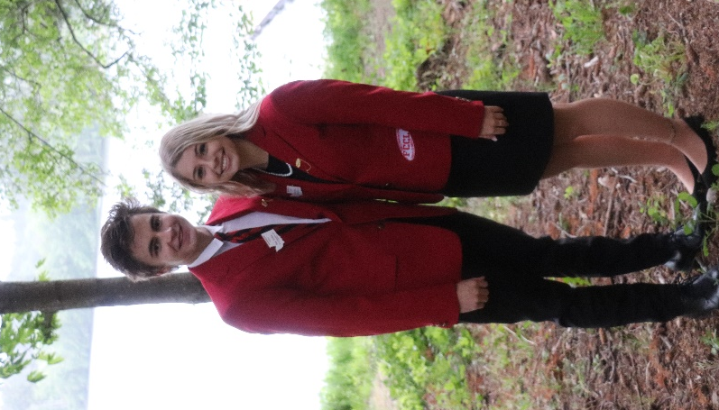
- Professional long sleeve white shirt with a pointed collar (oxford-style, with a button at the collar, suitable for a tie)
- FCCLA tie or FCCLA ascot
- Plain black dress shoes or pumps (no patent leather, suede, buckles, or bows)

*A document identifying where to purchase the specific shirt,
dress, and pants that elected officers will be required to wear
will be placed on the WA-FCCLA website in January and in
Washington Weekly.

Questions: If you have any questions or problems with which
your adviser and/or regional adviser cannot help you, please
contact:

Kathy Hahn FCCLA State Adviser

kathyhahn@wa-fccla.org

How Do I Decide Which Office to Run For??

- There are two different types of offices
  - State Vice President of a Region or
  - State At-Large Officer where your specific position is determined at the State Leadership Conference by a collaborative process

Requirements | State Vice-President of Region | At-Large Candidate
Application | XXX | XXX  Additional Officer Position form to complete
Procedure to Run | XXX – See Application Packet | XXX – See Application Packet  - Interview additional  - Presentation to Executive Council to determine office
Meetings – | Check the informational packet for which meetings are required or recommended. | Check the informational packet for which meetings are required or recommended.
Fall Leadership Meeting | XXXX – in charge of this meeting | Attendance Required
Regional Spring STAR Events Meeting | Attendance Required | XXXX – in charge of this meeting
Regional Spring Meeting during State Conference | XXXX- in charge of this meeting | Attendance Required
State Leadership Conference | XXXX | XXXX
Duties | See information below | See information below

Duties of Officers - State Vice President of a Region

1. The Vice Presidents of the Regions (10 total- one for each region) shall assume the responsibility for fall regional leadership meeting, elections, the spring regional leadership meeting, and submit a report of regional accomplishments at the state meeting.

Duties of Officers - At-Large Officer Positions

2. The President shall preside over all business meetings of the organization and state executive council, appoint the chairperson and members of special committees not otherwise designated in the bylaws, promote state and/or national projects, be a member (ex officio) of all committees, be responsible for STAR Events regional evaluation and serve as a member of the Washington FCCLA Board of Directors.

3. The Secretary shall keep the minutes of the state and executive council meetings and be responsible for STAR Events regional evaluation.

4. The Vice President of Finance shall be responsible for communicating with the regions about finances. Shall submit the executive council needs for the proposed budget for the coming year, report to the delegates assembled in a state leadership conference the financial status of the organization, be responsible for STAR Events regional evaluation and shall serve as a member of the Washington FCCLA Board of Directors.

5. The Vice President of Parliamentary Law shall see that order is maintained during meetings of the executive council. When amendments to the bylaws and other business of the organization are presented to the voting delegates, the Vice President of parliamentary law shall assist in conducting the meeting and be responsible for STAR Events regional evaluation. In the absence of the president, the Vice President of Parliamentary Law shall assume the responsibility of the president.

6. The Vice President of Programs shall provide leadership in planning and implementing the organization’s state and national programs for individual development and peer education and be responsible for STAR Events regional evaluation.

7. The Vice President of Recognition shall provide leadership in planning and implementing the organization’s recognition of member accomplishments and be responsible for STAR Events regional evaluation.

8. The Vice President of Public Relations shall provide leadership in planning and implementing the organization’s public relations materials and programs and be responsible for STAR Events regional evaluation.

9. The Vice President of Community Service shall provide leadership in planning and implementing the organization’s projects that make a difference in the school and community and be responsible for STAR Events regional evaluation.

10. The Vice President of Membership shall provide leadership in planning and implementing programs for membership promotion and development and be responsible for STAR Events regional evaluation.

11. The Vice President of Competitive Events shall provide leadership in planning and implementing the organization’s Competitive Events programs and be responsible for STAR Events regional evaluation.

Advisers to State Officers

Advisers to State Officers. The local advisers from each region serving on the state advisory board shall serve as regional advisers and assist their officers in fulfilling their duties (WA-FCCLA Bylaws, 2019, page 12).

What this means:
As an adviser to a state officer you too will serve in a role on the Washington State Advisory Board. You also agree to:
- Help your officer fulfill the duties of his/her office.
- Meet regularly with your state officer regarding progress toward regional and state goals and responsibilities.
- Travel with your state officer.
- Participate, as an active member, of the Washington FCCLA Advisory Board, and complete related committee assignments.
- Help plan and implement the Region’s Fall Conference (Adviser to State Vice-President) and Regional STAR Events (Adviser to At-Large Officer).
- Help plan and implement the State Leadership Conference.
- Provide guidance to FCCLA Advisers within the Region.
- Evaluate the commitment and work of your state officer.
- Complete special assignments based on your student’s office.
- When your officer is the only officer in your Region and they resign or must leave their office, you still hold a vital leadership role and are expected to attend any remaining Executive Council Meetings.

WA-FCCLA State Officer Candidate Procedures Checklist

Prior to State Leadership Conference:

1. Read the ENTIRE state officer candidate packet

2. Qualifications: In order to run for office, candidates must:
- be an affiliated member from an affiliated chapter
- have a cumulative grade point average of 2.5 or higher at the time of application
- have completed a minimum of two Power of One Projects – during present school year
- have completed Step One
- have completed at least one Family and Consumer Sciences education course

3. Complete and e-mail application materials in PDF format to the State Adviser and State Officer in charge of elections in your region. This includes:
- Completed application
- wallet-size photograph
- copy of transcript
- signed Code of Conduct Form
- recommendations
- School administrator (required)
- Employer, youth group or community leader, or teacher
- copy of your chapter affiliation form (your chapter must be affiliated by January 15th to have an officer candidate)

4. Write the meeting dates on your calendar. Officers must attend assigned required meetings/conferences or may be asked to relinquish their office.

5. Appropriate individuals have CAREFULLY READ, and signed, the Code of Conduct form.

6. At Large Candidates: Read the description of officer duties. Discuss those offices of interest with your adviser, parents/guardians, and school administrators. Complete the At-Large Officer Position Preference document which is included in application packet. This document should be email by February 1st with the rest of your application.

7. Prepare a presentation board no larger than 3' x 2' for the candidate fair at your regional spring meeting illustrating your qualifications. The display should be self-explanatory and may include posters, collages, a resume, or projects that demonstrate skill and competence. This board may include both FCCLA and other experience. (The presentation board could be on display at the Regional STAR Events held in the spring.) Display tables will be provided. If an easel is needed, please bring your own. At-Large candidate if elected, will bring presentation board to the selection meeting – Thursday morning.

8. For state leadership conference opening session, all officer candidates are to present a 20-second introductory commercial revolving around current state theme. Your name and school must be included. You may use a hand-carried prop. Remember the more you tie in the theme the more you will be remembered. No one may assist you with this presentation.

9. Prepare answers to ALL the following fact and opinion questions. You will answer one of the questions from each category during Spring Regional Meeting – Wednesday night:

Fact:
- What are the five components of the FCCLA Planning Process? Explain each step in the process and how it contributes to the overall success of your plan.

- Name one National Program. Describe a project you have worked on or could work on related to the National Program.

Opinion:
- Describe how an FCCLA activity has helped you become connected with your community or school.

- If you are talking to legislators, what would you say to them to encourage them to support Career and Technical Student Organizations.

10. Prepare a two-minute speech on this year’s theme.

11. As a State Officer you will be expected to know and explain facts about FCCLA. Review the following information to help you study for the FCCLA facts written test.

Basic Facts about FCCLA
- What the acronym FCCLA stands for
- Year FCCLA was founded
- Creed
- Mission
- Emblem
- Flower, Colors
- Motto
- Purposes
- What STAR stands for when referring to STAR Events
- Planning Process
- National Programs
- The official magazine of FCCLA
- Where the FCCLA National Headquarters is located
- Who the Washington FCCLA State Adviser is
- What the requirements are to become an FCCLA member?

Use the National Website as a resource for FCCLA Facts Written Test: www.fcclainc.org

12. OPTIONAL - If you want to create a resume and a one-page cover letter they could be sent to the chapters in your region after you have been approved as a candidate.

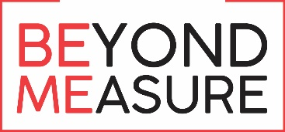
Washington Family, Career
and Community Leaders of America
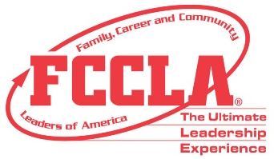

Election & Application Criteria

To ensure the high standard of our State Officer team, changes have been established to improve the election processes. The following are the requirements of each state officer candidate:

State Vice-President of a Region:
- Application to be filled out and emailed to State Adviser and State Officer in charge of elections in your region by February 1st
  - Wallet size Picture
  - Transcript
  - Signed Code of Conduct Form
  - Two letters of Recommendations
    - School Administrator (required)
    - Employer, youth group or community leader, or teacher
  - Printed Copy of your Chapter’s affiliation list
- Before state meeting
  - Create a presentation board 3’ x 2’ for the candidate fair and election process
  - Create a 20-second commercial revolving around current state theme
  - Prepare answers to fact and opinion questions
  - Prepare a 2-minute speech on this year’s theme for the election process
  - Study for your written test – Facts about FCCLA
- Written Test – will be given virtual in late February
- Wednesday, March 16th – there will be an officer candidate networking session in afternoon
- Opening Session – 20 second commercial
- Delegate Vote – at Spring Regional Meeting – March 16th – 8:30 – 9:00 pm
  - Present display board
  - 2-minute speech
  - Answer fact, opinion, and impromptu questions

State At-Large Officer
- Application to be filled out and emailed to State Adviser and State Officer in charge of elections in your region by February 1st
  - Wallet size Picture
  - Transcript
  - Signed Code of Conduct Form
  - Two letters of Recommendations
    - School Administrator (required)
    - Employer, youth group or community leader, or teacher
  - Printed Copy of your Chapter’s affiliation list

- Before state meeting
  - Create a presentation board 3’ x 2’ for the candidate fair and election process
  - Create a 20-second commercial revolving around current state theme
  - Prepare answers to fact and opinion questions
  - Prepare a 2-minute speech on this year’s theme for the election process
  - Study for you written test – Facts about FCCLA
- Written Test – will be given virtual in late February before you interview
- Interview – 5-10 minutes with panel of three-five adults, focusing on leadership qualifications and FCCLA experiences. The candidates will also present their 2-minute speech at the beginning of the interview process.
- Wednesday, March 16th – there will be an officer candidate networking session in afternoon
- Opening Session – 20 second commercial
- Delegate Vote – at Spring Regional Meeting – March 16th – 8:30 – 9:00 pm
  - Present display board
  - 2-minute speech
  - Answer fact, opinion, and impromptu questions
- Executive Council Vote, Thursday, March 17th – At-Large Officers will present their display board, might give their 2-minute speech, answer questions, and talk about the three officer positions they are interested in holding

During WA-FCCLA State Leadership Conference:
Wednesday, March 16, 2022

- During State Leadership Conference, all candidates will attend networking session. The time and place will be in the printed program. It is planned for 2:00 pm.

- State Leadership Conference opening session, all candidates will present their 20-second introductory commercial. Following the opening session, be prepared to participate in the candidate fair at your Spring Regional Meeting. Candidates will display their presentation boards and have the opportunity to respond to questions from the delegates as they informally review the displays and discuss qualifications.

- During the Spring Regional meeting, give your two-minute presentation on this year’s theme. You will be asked one fact and one opinion question from those listed above. You will also be asked one impromptu question (given to the regions by the state adviser). Impromptu questions are designed to test your ability to respond spontaneously and will further demonstrate your knowledge of FCCLA and your thoughts about leadership.

- Advisers to officer candidates must report to the STAR Events headquarters at 10:00 p.m. to pick up the letters to officer candidates. The letters will announce the results of the balloting process and should be opened in a private area with just the adviser and the officer candidate present.

Thursday, March 17, 2022
  - Newly elected state officers will meet with outgoing state officers for breakfast in the conference center. See conference program for time and room.

  - Newly elected state officers will meet in the morning to determine named officers’ positions. The time and place will be in the printed program. At-Large State Officers will need to bring their presentation board, 2-minute speech, and answers to the three offices you are interested in into this training. Lunch will be provided for the officers (you will need money to purchase a drink) during this training.

  - State Officers will work on their state Program of Work goals in the afternoon.

4. Advisers to state officers will meet for Adviser training. The time and place will be in the printed program. – The approximate time will be 1:00 pm – 3:00 pm.

Friday, March 18. 2022

- Installation Practice at 7:00 am - come prepared to wear:
Either a black woven straight skirt no shorter than 2” above the knee or black slacks and
Professional long sleeve white shirt with a pointed collar (oxford-style, with a button at the collar)

- State Officers and their Advisers – Informational meeting after State Leadership Conference – Time and place will be in the printed program. The approximate time will be 12:30-1:30 pm – if it is necessary to have to complete agenda items.

There will be a closed installation practice early on Friday morning for just the current and newly elected officers. Check your program for the time and location of this event.

Washington Family, Career and Community Leaders of America
2022-2023 State Officer Calendar

Your decision to be a candidate for a state office of Washington Family, Career and Community Leaders of America is an important one. The following should assist you in planning and scheduling to avoid conflict with other activities. Planning, implementing, and participating in meetings and conferences of FCCLA are essential duties of the WA-FCCLA State Officer. All meetings and conferences are **REQUIRED OF EACH OFFICER, AND THEIR ADVISER, unless otherwise stated. FCCLA is an integral part of FCS classes, and time in your classes is important for your personal success and to support your classmates and fellow FCCLA members. It will be necessary, however, for state officers to miss some days of class to participate in state leadership activities. In addition to the meetings/conferences listed, you may be asked to represent FCCLA at other meetings or activities held in your area. All arrangements for meetings and activities are made in cooperation with the officer, the FCCLA chapter adviser, parents, and the state adviser.

MEETINGS and CONFERENCES | WHO | PURPOSE
**Informational State Officer meetings  State Leadership Conference  March 17, 2022 and March 18, 2022  Following closing session | State Officers  Advisers to State Officers | - Review uniform requirements  - CTSO Leadership Retreat  - National Leadership Conference Responsibilities
**WA State CTSO Leadership Retreat  Tentatively  May 22nd (Noon) – May 25th (Noon) | State Officers  Advisers to State Officers | - Develop leadership skills  - Plan for National Leadership Conf.  - State Program of Work  - Plan state projects and check uniforms  - Fall and Spring Regional Meeting - VP
**National Leadership Conference  June 27 - July 3, 2022 • San Diego, CA  San Diego, CA | State Officers  Advisers to State Officers  (State officer must travel with a  local adviser) | - Prepare for annual activities  - State Office training  - Share and receive ideas/activities to bring back to WA and share
Capitol Leadership Conference  September/October 2022  Washington D. C. | State Officers  Advisers to State Officers | - Leadership and Advocacy Training
**Regional Fall Planning Meeting Optional  September/October 2022  (Date set by region) | State Officers  Advisers to State Officers | - Meet with other officers and advisers  - Plan Fall Regional Meeting
**Fall Regional Leadership Meeting  October 2022 (Date set by region) | State Officers  Advisers to State Officers | - Implement Fall Regional Meeting
**November Executive Meeting  November 7th & 8th 2022  Wenatchee, WA | At-Large Officers only  Advisers to At-Large Officers | - Plan: State Leadership Conference  - Regional STAR Events  - Review Program of Work goals
National Fall Conference, (Recommended)  November 11th – 13th  Columbus, OH | State Officers  Advisers to State Officers | - Leadership Training  - Competitive Events
**Regional STAR Events  January 2023  (Date set by region within state guidelines) | State Officers  Advisers to State Officers | - Conduct STAR Events
(Recommended)  Civic Advocacy Day  January 31st & February 1st, 2023 Olympia, WA | State Officers  Advisers to State Officers | - Meet with Legislators  - Advocate for FCS and CTSOs
**Spring Executive Council  March 13-14, 2023 - tentative  Wenatchee, WA | State Officers  Advisers to State Officers | - Finalize State Leadership Conference plans and evaluate year’s work
**State Leadership Conference  March 15-17, 2023 - tentative  Wenatchee, WA | State Officers  Advisers to State Officers | - Share year’s activities and present awards  - Conduct spring regional meeting and elections of state officers

2019-2020 - WA-FCCLA OFFICERS AND ADVISERS
RESPONSIBLE FOR FCCLA ELECTIONS
Region | Officer | Adviser
1 | No Officer | Kathy Hahn, State Adviser  Washington State Adviser  425-530-1907  kathyhahn@wa-fccla.org
2 | No Officer | Kathy Hahn  Washington FCCLA State Adviser  425-530-1907  kathyhahn@wa-fccla.org
3  Vice President | Hailey Littlefield  hlittlefield@wa-fccla.org | Tricia Littlefield  Bonney Lake High School  253.891.5700  tricia_littlefield@sumnersd.org
4 | No Officer | Kathy Hahn  Washington FCCLA State Adviser  425-530-1907  kathyhahn@wa-fccla.org
5  Vice President | Molly Rose Bates  mrbates@wa-fccla.org | Dawn Boyden  Lake Stevens High School  425.335.1515  Dawn_Boyden@lkstevens.wednet.edu
6  Vice President | Alexa Leddy  aleddy@wa-fccla.org | Cori Montgomery  Wenatchee High School  509-663-8117 ext. 39500  montgomery.cori@wenatcheeschools.org
7  Vice President | Gilena Provaznik  gprovaznik@wa-fccla.org | Cheryl Uceny  Kittitas Jr./Sr. High School  855-380-8848 509-968-3370 (fax)  Cheryl_uceny@ksd403.org
8  Vice President | Brynn Christensen  bchristensen@wa-fccla.org | Summer Henson  Royal High School  509.346.2256  shenson@royalsd.org
9  Vice President | Julian Meredith  jmeredith@wa-fccla.org | Courtney Schmidt  Tekoa High School  509-284-3401-X224  cschmidt@tekoasd.org
10  Vice President | Robyn Wright  robynwright@wa-fccla.org | Stephanie Tetrick  Kettle Falls High School  509-738-6388 ext.414 509-738-2670 (fax)  stetrick@kfschools.org

2022-2023 FCCLA STATE OFFICER
Mark the office you are running for below.
________State Vice President CANDIDATE

________At- Large CANDIDATE
Candidate Information
Candidate’s Name
Parent or Guardian’s Name
Parent or Guardian’s Phone Number
Parent or Guardian’s E-Mail Address
Birthday |  |  |  |  | Age |  |  |  | Grade  (next year)
Home Address
City |  |  |  |  |  | Zip code
Candidate’s
Cell Phone Number
Candidate’s Email
Candidate’s Cum. GPA
** Provide transcript**
Chapter Information
Chapter/School
Chapter Adviser
Chapter Adviser email
Chapter Adviser phone #
Principal
Principal email address
School phone #
Family and Consumer Sciences Classes
List all the Family and Consumer Sciences classes you have taken, and the year completed. Candidate must have a minimum of .5 credits of Family and Consumer Sciences classes by February 1st of the current year, and a minimum of a 2.5 GPA. A copy of your transcript with classes highlighted is required to be included with your application. If you took FCS classes in 6th-8th grade include that transcript or verification of grade(s) earned.

FCS Classes |  |  |  |  |  |  |  | Year Taken |  |  |  |  |  |  | Grade
All candidates must be a State and National affiliated member by January 15th of the current school year to apply.
How many years have you been an active FCCLA member? (including current school year)
Include a copy of your chapter affiliation form with your name highlighted.
I am competing in a STAR Event |  |  |  |  |  |  |  | STAR Event I am competing in:
I WILL NOT be competing in a STAR Event
Local FCCLA Chapter Involvement
Describe your involvement in your FCCLA school chapter…offices held, projects participated in, etc.:
Which of the following state/national activities have you participated in prior to February 1st of the current year?
# | Meeting |  |  |  |  |  |  |  |  |  |  | Year(s)
1 | National Leadership Conference
2 | Cluster/National Fall Conference
3 | STAR Event at Regional STAR Event Competition
4 | STAR Event at State Conference
5 | STAR Event at National Leadership Conference
6 | Advocacy Day
7 | Power of One: Better You
8 | Power of One: Family Ties
9 | Power of One: Working on Working
10 | Power of One: Take the Lead
11 | Power of One: Speak out for FCCLA
12 | Step One
# | Participated in which National FCCLA Programs? |  |  |  |  |  |  |  |  |  |  | Year
1 | Career Connections
2 | Community Service
3 | FACTS
4 | Families First
5 | Financial Fitness
6 | Power of One
7 | Stand Up
8 | Student Body
 | National Outreach Project
School and Community Participation
List your participation in other school and community activities besides FCCLA (include major activities, organizations you belong to, offices held, and awards or honors received.)
Community Activities |  |  |  | School Activities |  |  |  |  |  |  | Offices Held and Honors Received

Short Answer
Use only the space provided. Write one paragraph for each of the three topics below:
FCCLA has helped me become the person I am today because—
The qualities I feel I have that will help me be a leader in Family, Career and Community Leaders of America--
The three most important qualities of an effective leader are_____ because:
At-Large State Officer Candidates ONLY
Position Preferences

Name: ______________________________
Should you be selected as an FCCLA State Officer, your position will be announced at the Washington FCCLA State Conference. We would like to know your top three choices. Use only the space provided and write one paragraph for each choice explaining why you think you would be a good candidate for the position listed.
*The following page has a list and brief description of each position*
1st Choice
2nd Choice
3rd Choice
Adviser Approval: ___________________________

*There may be a chance you might be elected into a position that is not listed as one of your top 3 choices.

WA-FCCLA State Officer/ Candidate Code of Conduct Agreement

As an FCCLA State officer/officer candidate, I understand my behavior always should reflect credit to my family, my state, the national organization, and myself. Although the official assumption of an office begins following election, once I choose to run for an office, I agree to abide by the following conduct guidelines. I understand that the term of office is an entire calendar year (from one State Leadership Conference through the next) including the summer months and all school holidays.

Therefore, I will:
- Not consume, use, distribute or have in my possession drugs, alcohol, paraphernalia or illegal substances;
- Not break any civil/criminal law;
- Fulfill all state officer responsibilities, including rearranging my schedule and activities to attend required meetings/conferences in full.
- Follow all local school rules.
- Behave in a manner befitting a State Officer and leader.
- Maintain a minimum cumulative 2.5 GPA.

I understand not abiding by the above results in loss of Office

I also understand the following expectations, therefore I will:

Related to my office:
- Make the office to which I am elected first priority this year. I will arrange consistent meeting times with my local adviser to complete duties related to my office and honor timelines established for regional and state responsibilities.
- Fulfill the duties of my specific office and the general duties of state officers, as described in the handbook under the direction of my local adviser.
- Come prepared to all Council meetings and other functions.
- Maintain active participation in my local chapter.
- Maintain professional behavior/conduct myself as a leader. As a State Officer, I am a visible role model; my behavior should be an example for the entire FCCLA membership. It is always important to be aware of this visibility, not only during official FCCLA events.
- Dress according to FCCLA Dress Code, as I reflect the image of FCCLA (refer to Handbook).
- Comply will all policies of the association.
- Share public information appropriately. Information included on personal Web pages and social networking sites (Facebook, Instagram, Snapchat, Twitter, Tik Tok, etc.) must be consistent with the Mission and Purposes of FCCLA. This includes, but is not limited to, links, photos, videos, chat rooms, screen names, comments, likes and blogs.
- Give permission to be photographed and published.

Related to my behavior at meetings/conferences:
- Inform adviser and/or chapter adult of my location at all times.
- Participate in conference general sessions and workshops indicated on the program.
- Use all electronic devices, including cell phones, in an appropriate manner, including keeping them on privacy mode and not communicating during scheduled sessions and workshops.
- Respect hotel/convention center employees, guests, the community, and personal property.
- Respect hotel/convention/meeting property. If an officer is found responsible for stealing or vandalism, the officer and his/her parents or guardian will be expected to pay all damages. This includes the removal of items from hotels.
- Minimize noise in all public areas and hotel rooms, including TV’s and other forms of media, particularly after established curfew times.
- Meet with people, other than roommates, only in public places.
- Respect the dignity and privacy of roommates as well as all other event participants.
- Maintain professional relationships: recognizing that inappropriate physical contact with other members or students is not acceptable. Refrain from demonstrating public displays of affection.
- Remain in assigned room after curfew.

Officer Candidate Agreement
I understand that failure to comply with the above expectations may result in loss of privileges/other disciplinary action as determined by my local and/or state adviser. School rules supersede all Washington FCCLA rules. These rules apply to local, regional, state and nationally sponsored FCCLA events. (Refer to Ultimate Leadership Handbook).

Candidate’s Signature______________________________________Date_________________

We have read the preceding information and reviewed the officer expectations and calendar of events and we approve ___________________________________________________________________ as a candidate for an FCCLA state office. We are aware of the duties and responsibilities, including travel, if the candidate is elected to office and will support his/her participation in all FCCLA events.

Chapter Adviser’s Signature____________________________________________________

Principal’s or Superintendent’s Signature_________________________________________

CTE Director’s Signature_______________________________________________________

Parent’s or Guardian’s Signature_______________________________________________

Additional Signatures required for Middle School 9th Grade Candidates:
High School Chapter Adviser’s Signature_________________________________________

High School Principal’s Signature_______________________________________________

Adviser/District Agreement
We agree that:
- The local adviser is the primary chaperone for the elected state officer and will accompany the elected state officer to all FCCLA state officer functions.
- The local adviser will serve on the FCCLA State Advisory Board. As a member of the WA-FCCLA State Advisory Board, we understand that the adviser to a state officer also holds a leadership position in the FCCLA region and state. We agree to support the adviser in this leadership role (substitute teacher, travel).
- The district will assume responsibility for any expenses related to an additional chaperone, should the district require one, when the adviser and officer are of opposite genders.

Chapter Adviser’s Signature __________________________________________________

Principal’s or Superintendent’s Signature_________________________________________

CTE Director’s Signature_______________________________________________________

Responsibilities/Obligations
WA-FCCLA State Officers

Completion of this application signals your willingness to commit your time to FCCLA and to uphold behavior expectations appropriate for a State Officer of FCCLA! If elected, the candidate is REQUIRED to attend assigned meetings/conferences and leadership training on in the Washington State Officer Candidate Informational Packet. Members who cannot commit to attending the meetings identified should reconsider whether this is a good time to run for a state office. The elected officer should plan to have a designated time in his/her schedule to meet with the local adviser each school day. Individuals who do not attend the assigned required meetings/conferences may be asked to relinquish their office.

FCCLA State Officers represent not only the state, but also their region, school, family, community, and chapter. Therefore, they should maintain professional conduct at all times and follow the Washington FCCLA Code of Conduct. Individuals will lose their office if they are caught with (or using) illegal substances, and/or breaking any civil or criminal law(s).

Violations of other Code of Conduct rules will result in a written warning from state staff and a supplementary state officer contract addressing the Code of Conduct infraction(s). The Code of Conduct obligations will be reviewed, and the student will sign the supplementary state officer contract. Any further violation(s) will result in the removal from office at the discretion of state staff.

State Officers are reimbursed for at least part of travel and housing expenditures for executive council meetings and the annual State Leadership Conference. All other expenses (i.e. meals and uniform) are the responsibility of each officer.

An officer must maintain a minimum cumulative 2.5 Grade Point Average (GPA). Advisers will be responsible for requesting a grade status report at the end of each grading period. Officers with a grading period GPA less than 2.5 will have one grading period to be in good standing or relinquish their office. At the end of any grading period they must be in good standing or be put on probation for one grading period.

All application materials must be sent electronically in PDF format to State Adviser and State Officer in charge of elections in your region on or before the due date of February 1.

Responsibilities/Obligations
Advisers to and Schools/Districts of
WA-FCCLA State Officers

The FCCLA State Officer requires the support of her/his adviser, school and school district. The state officer needs to attend all of the required meetings throughout his/her time in office. School districts and advisers commit to support their officers and help them fulfill their duties. Individual officers who do not attend the assigned required meetings/conferences may be asked to relinquish their office.

The Adviser to a State Officer holds an important leadership role in the state. In addition to coaching the state officer for the completion of assigned and assumed duties, she/he provides adult leadership for both regional and state FCCLA activities. Instruction for the assumption of these duties is provided at executive council meetings and state and national leadership conferences. When there is only one State Officer in the Region and that Officer resigns or leaves their office, the Adviser still holds a vital leadership role and is expected to attend the remaining Executive Council Meetings.

The school and school district provide support for both of these leadership roles helping insure that both the officer and adviser are able to travel to FCCLA events, supporting each in the time needed to complete leadership responsibilities, and when a district requires an additional chaperone due to gender differences between officer and adviser, providing both a chaperone and financial support for that chaperone.

Many travel, housing and meal expenses for advisers to state officers are covered by WA-FCCLA for executive council meetings and the annual State Leadership Conference. All other expenses (i.e. meals while traveling to an event) are the responsibility of each district.

All application materials must be sent electronically in PDF format to State Adviser and State Officer in charge of elections in your region on or before the due date of February 1.

Name: _________________________________
FCCLA State Officer Application Check List

These two pages are a Check List for completing the WA-FCCLA State Officer Application process.

application form

_______ At-Large Officer candidates only – Position Preference form with Adviser’s Signature

_______ A wallet size photograph

_______ Attached a current copy of transcript to the application (must have a 2.5 cumulative G.P.A. at the time of this application).

_______ Signed the Code of Conduct Forms

_______ Included two recommendations from: (which address your leadership, citizenship, scholarship, and maturity level)
- School administrator (required)
- Employer, youth group or community leader, or teacher

_______ Included a printed copy of your chapter affiliation list, demonstrating that the candidate was affiliated prior to January 15, 2022.

_______ E-mailed and received by State Adviser and State Officer in charge of elections by February 1.

FCCLA State Officer Application
Check List, continued

The following are the additional items you need to do before coming to State Leadership Conference

_______ Put all required meeting dates on your calendar for the upcoming year and plan other activities around those dates. Officers must attend assigned required meetings/conferences or may be asked to relinquish their office.

_______ Prepare a presentation board – 3’ x 2’ for candidate fair and election process.

_______ Prepare a 20-second introductory commercial around current state theme.

_______ Prepare answers to fact and opinion questions provided in officer candidate informational packet.

_______ Prepare a 2-minute speech on this year’s theme.

_______ Study basic FCCLA facts.

_______ OPTIONAL - create resume and one-page cover letter to send to chapters in your region.

_______ Make sure you have the appropriate FCCLA dress.

_______ If elected – read over FCCLA dress that you will need for installation.

HONORARY MEMBERSHIPS

Honorary memberships are a special way of recognizing individuals who have supported, made significant contributions, and/or promoted Family, Career and Community Leaders of America and family and consumer sciences education. Honorary memberships may be awarded at the state or chapter level.

STATE—Applications for state honorary memberships may be submitted for individuals who qualify in one of the following categories.

1. Chapter Parents and Citizens: Have made direct contributions (time, effort, talents, support, guidance, and/or aid in interpreting the FCCLA program) to FCCLA by participating in business and social meetings, assisting with conventions, and/or acting as a coordinator between the chapter and the community on the regional and/or state level.

2. Community Leaders: Have held statewide leadership positions in business, industry, government, news media, or organizations and have the capacity to promote FCCLA and FACSE.

3. Chapter Advisers: Have made direct contributions to FCCLA in ways that are readily recognizable as outstanding or unique and in addition to regular duties.

4. State FCCLA Adviser: Has given three or more years of service to working with chapters on national, state, and local problems over and above the responsibilities of the position.

Applications for state honorary membership should be well organized and contain concise evidence. Those reviewing the applications will not know each candidate; therefore, the application must be complete. Use the honorary membership form for submitting application.

CHAPTER—The following qualifications are suggested as guides for evaluating persons thought to be worthy of chapter honorary membership.

1. Chapter Parents: Have been active in FCCLA for two or more years or by attending business and social meetings, assisting with special meetings, regional meetings, etc.; provided transportation for FCCLA trips; acted as adviser on chapter trips; and helped to promote community activities.

2. Chapter Advisers: Have encouraged and promoted a strong desire in the members to continue FCCLA and FACSE and who have done outstanding work beyond their usual duties.

3. Chapter Members: Have made outstanding contributions to FCCLA and to the FACSE program.

- Citizens: Have promoted and/or contributed to the local FCCLA program or have the potential to do so.

WASHINGTON FAMILY, CAREER AND COMMUNITY
LEADERS OF AMERICA
HONORARY MEMBERSHIP
Recommendation Form

Please type or print

Name of candidate:

Home address:
Street City Zip

Present position:

How long has the candidate held this position?

Category (check one): Chapter parents and citizens
Community leaders
Chapter advisers
State FCCLA adviser

Why do you think this candidate is particularly deserving of this honor?

*What specific contribution(s) has the candidate made at the regional level?

Give examples:

*What specific contribution(s) has the candidate made to the state organization?

Give examples:

*What specific contribution(s) has the candidate made to any other FCCLA activity?

Give examples:

Please have two letters of recommendation written about this candidate, which describe the qualities and contributions (potential contributions for community leaders) of the candidate to FCCLA. The letters may be written by the superintendent, principal, teachers, chapter members, or a community leader familiar with the candidate’s work. They should be sent directly to the state adviser by February 1.

*Omit for candidates under “Community leaders” category.

Hall of Fame

Hall of Fame recognition is a special way of acknowledging individuals who have dedicated, made significant contributions, and legacy in FCCLA in state of Washington.

Criteria:
- 10 or more years of service in any way (member, adviser, board member, evaluator, volunteer, presenter, etc.)
- Serve as a State or National Officer for a total of three years (or more)
- Development of an initiative or program that is adopted by WA FCCLA and implemented for three years or more
- Serve as a sponsor or partner for 5 years or more
- Sponsor legislation supporting FCCLA

Applications for state Hall of Fame recognition should be well organized and contain concise evidence. Those reviewing the applications will not know each candidate; therefore, the application must be complete. Use the Hall of Fame recognition nomination form for submitting application.

Self-Nominations will be accepted. Also, if you are nominated by someone and your application is incomplete - the recognition reviewing committee may contact the nominee to provide the missing information.

WASHINGTON FAMILY, CAREER AND COMMUNITY
LEADERS OF AMERICA
HALL OF FAME
Nomination Form

Please type or print

Name of candidate:

Home address:
Street City Zip

E-Mail Address: ___________________________________________________

Cell Phone Number: _______________________________________________

Contributing position:

How long has the candidate held this position?

Category (check one): Chapter advisers
Chapter parents and citizens
Community leaders
FCCLA Member/Alumni
State FCCLA adviser

- Candidate’s years of service to FCCLA (formerly FHA/HERO)

- Biography of candidate’s overall participation and contributions to FCCLA. Please list any major dates and details about their history with the organization and impact made.

- List all the contributions the candidate has made to FCCLA at the regional level. Give examples

- List all the contributions the candidate has made to FCCLA at the state level. Give examples

- Please explain in detail how the candidate’s contributions have made a legacy impact on WA-FCCLA.
__
________________________________________________________________________________________________________________________________________________________________________________________________________________________________________________________________________________________________________
________

Please have one or more letters of recommendation written about this candidate, which describe the qualities, contributions, and legacy left by the candidate to Washington FCCLA.

The letter(s) of recommendation should be attached with this form and be sent directly to the State Adviser, Kathy Hahn (kathyhahn@wa-fccla.org) by February 1.

Nominator: ________________________________________________ or

Self-Nominated: ______________________________________________

Any questions can be directed to Kathy Hahn, WA State FCCLA Adviser by email or by calling 435-530-1907.

SCHOLARSHIPS

Washington FCCLA offers two $1,000 scholarships to active FCCLA members who have achieved academic excellence. There are three categories of scholarships offered:

• Applicants who plan to major in FACSE.
• Applicants who plan to prepare for a FACSE-related occupation.
• Applicants currently in a university, community, or technical college planning to enter FACSE as a major.

In years where there are no qualifying applicants in one of the categories, then more than one scholarship may be awarded in another category.

The scholarships are awarded in the names of:

Anita Worth Berry
Laura E. McAdams
Dean Velma Phillips
Ailsie M. Stevenson
Grace G. Granberg

The scholarships are awarded each year at the annual state meeting. Each one thousand dollar scholarship is paid over a two-year period to the recipient.

To be eligible for an FCCLA scholarship, an applicant must meet the following qualifications:
1. Have a grade point average of 3.0 or above.
2. Be an active member of a local chapter or have been an active member while in high school.
3. Plan to or be enrolled in:
- Study FACSE at one of Washington's accredited four-year universities (Category I).
- Enter a one- or two-year training program for a FACSE-related occupation in a Washington community or technical college (Category II).
- Enter FACSE as a major and be currently enrolled in a university in Washington (Category III).

Note: If there are no applicants intending to attend school in Washington State the scholarship may be awarded to an applicant planning to attend a school out of state.

Use the forms in the Chapter Adviser Manual. Completed application and recommendations must be received by the published due date.
WASHINGTON FAMILY, CAREER AND COMMUNITY
LEADERS OF AMERICA

Scholarship Application

Please type or print

NAME: GRADE LEVEL:

HOME ADDRESS:

HOME PHONE: ( )

CURRENT CHAPTER OR SCHOOL:

1. Scholarship Category

Plan to study FACSE at one of Washington’s accredited four-year universities. (check one)
Central Washington University
Seattle Pacific University
Washington State University

Plan to enter a one- or two-year training program for a FACSE-related occupation in a Washington community or technical college.
Indicate college:

2. Eligibility

A. Grade point average: (3.0 or higher)

B. Years of FCCLA membership:

C. Chapter in which membership was held:

3. Recommendations:
Two letters of recommendation are part of this application. Ask two individuals who know your leadership and academic strengths to complete the scholarship recommendation form. Please request that the forms be emailed to State Adviser and to the Executive Director prior to February 1.

4. Written Application

Respond to Questions A, B, and C on the next page. Do not use additional pages.

DATE: SIGNATURE:
Send completed application to the FCCLA State Adviser and Executive Director.
WASHINGTON FAMILY, CAREER AND
COMMUNITY LEADERS OF AMERICA

Scholarship Application—Page 2

A. Which area of FACSE or FACSE-related occupations will be your major focus?

B. Why have you selected this area or occupation?

C. State how you have participated in activities that directly relate to the purposes of FCCLA in the following areas: chapter, home, school, and community. (You may use Power of One, STAR Events, national program activities, or post-secondary leadership activities as examples.)

Please reproduce as needed
WASHINGTON FAMILY, CAREER AND COMMUNITY
LEADERS OF AMERICA

Scholarship Recommendation

Thank you for taking a few moments to recommend
as a potential scholarship recipient. Please use your personal knowledge of this individual to respond to the following questions.

1. How long have you known the candidate and in what capacity?

2. What is your personal knowledge of the candidate's leadership and academic accomplishments?

3. What, in your opinion, is the candidate's potential for achieving personal and academic goals?

4. What additional comments about the candidate would you like to make that the reviewer should know?

Name: Date:

Address:

Phone: ( )

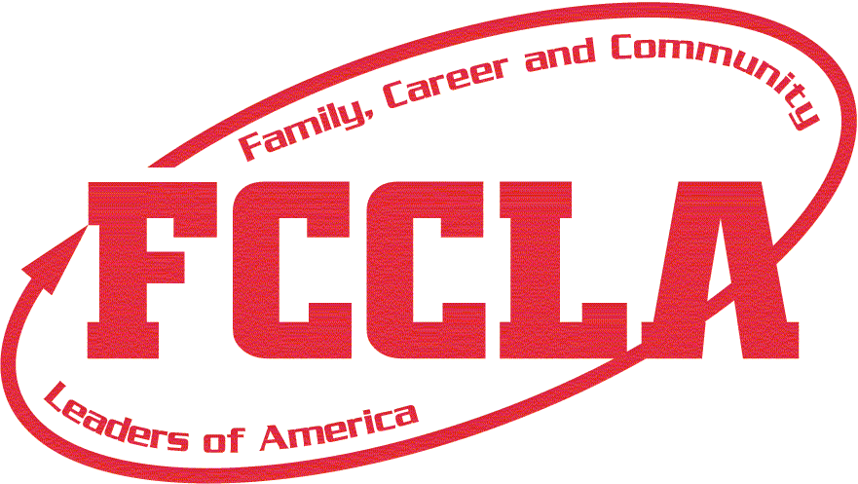

Washington Family, Career and Community
Leaders of America

Bylaws
Updated - May 2019

Article I

Name—Sponsor—Purposes

Section 1. Name. The name of this organization shall be Washington Family, Career and Community Leaders of America, Affiliate of Family, Career and Community Leaders of America, Incorporated.

Section 2. Sponsor. The sponsor of the organization shall be Family and Consumer Sciences Education, Office of Superintendent of Public Instruction. The location of the state headquarters of the organization shall be determined by the program supervisor of FACSE and shall function as a part of the FACSE program.

Section 3. Mission. The mission of FCCLA is to promote personal growth and leadership development through FACSE. Focusing on the multiple
roles of family member, wage earner, and community leader, members develop skills for life through:
- Character development.
- Creative and critical thinking.
- Interpersonal communication.
- Practical knowledge.
- Career and Technical preparation.

Section 4. Purposes. The purposes of the organization shall be:
- To provide opportunities for personal development and preparation for adult life.
- To strengthen the function of the family as a basic unit of society.
- To encourage democracy through cooperative action in the home and community.
- To encourage individual and group involvement in helping achieve global cooperation and harmony.
- To promote greater understanding between youth and adults.
- To provide opportunities for making decisions and assuming responsibilities.
- To prepare for the multiple roles of men and women in today’s society.
- To promote FACSE and related occupations

Article II
Organization

Section 1. Structure. Washington FCCLA shall consist of all affiliated chapters composed of the individual members within the boundaries of the state.

A. Affiliated Chapters. A chapter may be affiliated in each middle, junior, or senior high school in which FACSE instruction is offered. The chapter shall be composed of students possessing qualifications for membership.

1. Organization. A chapter may be organized whenever, in the judgment of the teachers, students, administrators, and parents, it would be advantageous to do so. Each chapter must have a minimum of twelve affiliated members. The Executive Director and/or State Adviser is authorized to recognize a chapter of less than twelve members if the chapter makes a request for exception in writing. Chapters will emphasize:

a. FACSE.
b. FACSE related occupations.
c. And/or a combination of FACSE and FACSE related occupations.

2. Affiliation. Annual affiliation shall be made online or on forms provided by the national association.

B. Membership. To be eligible for membership, an individual must meet the qualification of one of the following categories:

1. Active Member. Students enrolled in a FACSE and/or related occupations class in a middle, junior, or senior high school, or previously so enrolled, who have paid annual state and national dues shall be eligible for membership in the affiliated chapter of the school, which they attend. Such members may continue active membership during the time they are enrolled in a middle, junior, or senior high school. Active members shall be eligible to vote, hold office, make motions, and participate in state and national programs.

2. Alumni Member. Former active members and other adults who share the goals and purposes of FCCLA and its programs who wish to support the continuing development of FCCLA youth shall be eligible for Alumni membership. Alumni members shall not be eligible to hold office, make motions, or vote.

3. Honorary Member. Washington FCCLA may, by a three-fourths vote of the state executive council, confer on any person the title of honorary member. This title shall be conferred only upon a person who has rendered outstanding service or who has capacity to advance the FCCLA program. The state executive council shall determine the number of state honorary memberships that may be awarded. Honorary members shall have the privilege of attending the meetings of the organization.

4. Corporate Member. Corporate entities that share the goals and purposes of FCCLA and its programs who wish to support the continuing development of FCCLA youth shall be eligible for corporate membership. Corporate membership shall include contributing, bronze, silver, gold and STAR categories with the fees to be determined by the Executive Council. Corporate members shall not be eligible to hold office, make motions, or vote.

5. Business and Professional Member. Adults who share the goals and purposes of FCCLA and its programs who wish to support the continuing development of FCCLA youth shall be eligible for Business and Professional Membership. Business and Professional members shall not be eligible to hold office, make motions, or vote.

Article III
Fiscal

Section 1. Dues.

- Annual state membership dues for active members shall be fixed by the state executive council subject to approval by a majority of the voting delegates present at a state leadership conference of the Washington FCCLA.

- State and national dues for each member shall be forwarded to the national organization prior to May 1 annually.

- Washington FCCLA alumni member dues will be determined by Washington FCCLA alumni leadership. Washington FCCLA alumni dues shall be paid through the Washington FCCLA association and will be split, by decision of the Washington FCCLA alumni, to support both the alumni and Washington FCCLA operations.

D. Dues for national Alumni and Associate members shall be determined by FCCLA, Inc.

E. The chapter executive council shall determine local membership dues subject to approval by the members of the chapter. Such dues shall be in addition to the national and state dues.

Section 2. Fiscal Year. The fiscal year shall be September 1 through August 31.

Section 3. Budget. The preparation of the budget shall be the responsibility of the Executive Director and/or State Adviser. It shall be submitted to the state advisory board, executive council and Board of Directors for adoption.

Section 4. Audit. The financial statement of all income and expenditures prepared by the Executive Director and/or State Adviser shall be externally reviewed annually. That report shall be presented to the state advisory board, executive council and Board of Directors for approval.

Section 5. Dissolution or Liquidation. Upon final dissolution or liquidation of Washington FCCLA, and after the discharge or satisfaction of all outstanding obligations and liabilities, the remaining assets of the state association shall be used by the state advisory board and/or Board of Directors in accordance with the purposes of the national organization or be transferred to a government instrumentality or a qualified exempt organization within the meaning of Section 501 (c) (3) of the Internal Revenue Code of 1954.

Article IV
Officers

Section 1. State Officers. The state organization shall have 20 elected officers. Such officers shall be members of the state executive council. The designation of the named officer’s title shall be determined through a collaborative process by the incoming members of the executive council. Officers of the organization shall be:
1 President
10 Vice Presidents
1 Secretary
1 Vice President of Finance
1 Vice President of Parliamentary Law
1 Vice President of Programs
1 Vice President of Public Relations
1 Vice President of Community Service
1 Vice President of Membership
1 Vice President of Competitive Events
1 Vice President of Recognition

Duties of Officers.

- The President shall preside over all business meetings of the organization and state executive council, appoint the chairperson and members of special committees not otherwise designated in the bylaws, promote state and/or national projects, be a member (ex officio) of all committees, be responsible for STAR Events regional evaluation and serve as a member of the Washington FCCLA Board of Directors.

- The Vice Presidents of the Regions shall assume the responsibility for fall regional leadership meeting, elections, the spring regional leadership meeting, and submit a report of regional accomplishments at the state meeting.

- The Secretary shall keep the minutes of the state and executive council meetings and be responsible for STAR Events regional evaluation.

- The Vice President of Finance shall be responsible for communicating with the regions about finances. Shall submit the executive council needs for the proposed budget for the coming year, report to the delegates assembled in a state leadership conference the financial status of the organization, be responsible for STAR Events regional evaluation and shall serve as a member of the Washington FCCLA Board of Directors.

- The Vice President of Parliamentary Law shall see that order is maintained during meetings of the executive council. When amendments to the bylaws and other business of the organization are presented to the voting delegates, the Vice President of parliamentary law shall assist in conducting the meeting and be responsible for STAR Events regional evaluation. In the absence of the president, the Vice President of parliamentary law shall assume the responsibility of the president.

- The Vice President of Programs shall provide leadership in planning and implementing the organization’s state and national programs for individual development and peer education and be responsible for STAR Events regional evaluation.

- The Vice President of Recognition shall provide leadership in planning and implementing the organization’s recognition of member accomplishments and be responsible for STAR Events regional evaluation.

- The Vice President of Public Relations shall provide leadership in planning and implementing the organization’s public relations materials and programs and be responsible for STAR Events regional evaluation.

- The Vice President of Community Service shall provide leadership in planning and implementing the organization’s projects that make a difference in the school and community and be responsible for STAR Events regional evaluation.

10. The Vice President of Membership shall provide leadership in planning and implementing programs for membership promotion and development and be responsible for STAR Events regional evaluation.

11. The Vice President of Competitive Events shall provide leadership in planning and implementing the organization’s Competitive Events programs and be responsible for STAR Events regional evaluation.

Section 2. Qualifications. Qualifications of candidates for state office are defined in the policy document.

Section 3. Term of Office. The term of office shall be for one year or until a successor is installed.

Section 4. Vacancies. Appointments for vacancies (other than the president) that occur before one-half of the term of office has expired shall be determined and/or made by the state executive committee and state president. If the office of president becomes vacant, the Vice President of Parliamentary Law shall assume the office and duties of the president.

Article V
Nomination and Election

Section 1. Nomination. Candidates for state office shall be nominated by the local chapters.

- Each region shall elect one undesignated State Officer and one State Vice President.

B. Each chapter may submit no more than one candidate for each office.

C. Nominations from chapters shall be mailed to the State Vice President of the region by a specified date.

Section 2. Election of Officers. Election procedures shall be determined by the executive council and advisory board. The candidate receiving the highest number of votes for the office shall be elected and shall assume office at the close of the annual state leadership conference.

Article VI
State Leadership Conferences

Section 1. Annual State Leadership Conference The annual state leadership conference shall be held at such time and place as the state executive council and state advisory board shall determine. The purpose shall be to hear the reports of officers and committee chairpersons, to promote the program of work, and to transact such other business as may properly come before it.

Section 2. Delegates.

- Voting Delegates (votes). Each chapter shall be entitled to at least one voting delegate for the first 12 members and an additional voting delegate for each 25 members or portion thereof with a maximum of ten voting delegates.

1 to 25 active members = 1 vote
26 to 50 active members = 2 votes
51 to 75 active members = 3 votes
76 to 100 active members = 4 votes
101 to 150 active members = 5 votes
151 or more active members = 6 votes etc.

Chapters affiliated through the middle level program will be assumed to have 50 members and therefore two voting delegates. A formula of “500/number of programs (assumed one program per school) involved = number of members” will determine the number of voting delegates for chapters affiliated through urban affiliation.

- All Other Delegates. Each chapter shall be entitled to send delegates according to a quota set by the state executive council and state advisory board.

Section 3. Voting. Voting delegates designated from the chapter’s official delegation may cast the number of votes to which a chapter is entitled. Voting delegates and State Officers shall have the privilege of making motions, debating issues, and voting. The privilege of discussion may be extended to the nonvoting representative upon the consent of delegates.

Section 4. Special Meetings. Special meetings may be called by the state executive council and the state advisory board when the need arises.

Section 5. Quorum. A majority of the voting delegates shall constitute a quorum.

Article VII
State Advisory Board

Section 1. State Advisory Board. The state advisory board shall be composed of:

- A person responsible for FACSE, Office of Superintendent of Public Instruction, who shall serve as chairperson.

- The Executive Director and/or State Adviser of Washington FCCLA.

- A minimum of one FACSE Educator from each in-state university offering a FACSE teacher preparation program.

- Local advisers serving as advisers to State Officers in each of the state’s regions.

E. Persons at-large to be designated by the State Executive Committee as needed.

Section 2. Term of Office. The length of service of advisory board members will be one year or as determined by the state executive committee.

Section 3. Duties. The duties of the advisory board shall be to:

- Serve in an advisory capacity to the state executive council.

- With executive council, recommend policies and procedures to Board of Directors.

- Consult with the Executive Director and/or State Adviser on work of the organization.

D. With the executive council, plan and implement annual state leadership conference, and assist officers in the execution of both regional and state duties.
- With the executive council, offer consultation in case an emergency arises which results in cancellation of the annual state leadership conference.

- With the executive council, determine the procedure for electing State Officers.

Section 4. Meetings. Regular meetings of the state advisory board shall be winter and spring, the time and place to be determined by the Executive Director and/or State Adviser. Special meetings may be called by the executive committee. A majority of the membership of the state advisory board shall constitute a quorum.

Section 5. Executive Committee. The executive committee of the state advisory board shall be composed of the Washington FCCLA Executive Director and/or State Adviser and the OSPI program supervisor of FACSE. This committee shall act in time of emergency to transact such business as requires immediate attention.

Article VIII
State Executive Council

Section 1. The State Executive Council. The elected State Officers compose the state executive council. A national officer from Washington State shall be a member of this council. The State Adviser shall serve as official adviser to the council.

Section 2. Duties. The executive council shall:

- Be responsible for planning and promoting the state program of work.

- Recommend the establishment of programs, projects, and activities.

- With the state advisory board, plan and implement the program for the state leadership conference and other meetings sponsored by the state organization.

- Interpret and advocate the goals and program activities of FCCLA to groups and individuals within and outside the organization.

- Determine the business to be brought before the delegates at the annual meeting.

- With the state advisory board recommend policies and procedures to Board of Directors.

G. With the state advisory board, offer consultation in case an emergency arises with results in cancellation of the annual state leadership conference.

- With the state advisory board, determine the procedure for electing State Officers.

Section 3. Committees. There shall be the following standing committees: standing, executive council work, and special.

- Standing committees. Each committee chairperson shall submit a plan of work for the current year for approval of the state executive council. The committee chairperson shall report to the members at the annual state leadership conference and submit a written report to the State Adviser.

- The program of work committee shall be responsible for developing the state goals and projects and planning for the implementation of national programs.

- The public relations and membership committee shall be responsible for promoting state and national projects encouraging and recognizing active participation of the organization’s members and chapters.

- The honorary membership committee shall be responsible for the selection of honorary members within established guidelines.

B. Executive Council Work Committees. There shall be executive council work committees to carry out planning of state association business. The committees shall be composed of executive council members and be appointed by the State Adviser.

C. Special Committees. Special committees may be appointed by the president to carry on the work of the organization with the approval of the State Adviser.

ARTICLE IX
Board of Directors

Section 1. The Board of Directors. The legal governing body of the Washington Family, Career and Community Leaders of America shall be the state Board of Directors (may hereafter be referred to as the Board). The primary functions of the Board shall be to set policy relating to program and fiscal matters and to be responsible for sound management.

Section 2. Term of Office. Board members shall agree to serve a term of one, two, or three years on the Board of Directors of the Washington Association of Family, Career and Community Leaders of America. Terms of Board of Director memberships begin and end immediately after the State Leadership Conference in the spring.

Section 3. Duties. Board of Directors members shall:

- attend all regular and special meetings of the Board and to serve on committees as assigned.

- demonstrate an active interest in family and consumer sciences education and in FCCLA’s mission, goals, programs, and activities.

- abide by and support all decisions, policies, and programs adopted by the Board. They shall not act independently on matters that should be decided by the entire Board, keeping the mission statement of Family, Career and Community Leaders of America as the focal point.

- promote interest and active participation in the organization on the part of the membership and representative groups.

- agree to represent Family, Career and Community Leaders of America when called on by the Board president, State FCCLA Adviser, or FCCLA specialist(s).

- review suggested amendments and formulate proposed amendments to the bylaws, and vote on the proposed budget.

Section 4. Committees. There shall be the following committees: program, communications, finance, nominating, work and special. The President may appoint special committees as needed to carry out the work of the Board.

- Standing committees. Each committee chairperson shall submit a plan of work for the year and shall report upon that plan to the Board at regularly scheduled meetings.

- The program committee shall be responsible for developing goals and projects and planning for the implementation of such.

- The communications committee shall be responsible for maintaining necessary lines of communication between the Board, the Advisory Board and the Executive Council.

- The finance committee shall be responsible for establishing an annual budget, determining and implementing fundraising, and overseeing the financial health of the organization.

- The nominating committee shall solicit nominations for new Board members.

B. Board of Directors Work Committees. There shall be board of directors work committees to carry out state association business. The committees shall be composed of Board members and be appointed by the Board president.

C. Special Committees. Special committees may be appointed by the Board president to carry on the work of the organization.

ARTICLE X
Regions

Section 1. Regions. There shall be ten designated regions of Washington FCCLA composed of the counties and portions of counties as follows:

- Region 1 Kitsap, Clallam, Jefferson, and Mason
- Region 2 Grays Harbor, Pacific, Lewis, Wahkiakum, Cowlitz, Clark, and Skamania
- Region 3 Pierce and Thurston
- Region 4 King
- Region 5 Whatcom, Skagit, Snohomish, Island, and San Juan
- Region 6 Okanogan, Douglas, Chelan, and Grand Coulee Dam, Quincy, Republic, and Curlew School Districts
- Region 7 Kittitas, Yakima, and Klickitat
- Region 8 Benton, Franklin, Grant, and Columbia-Burbank and Othello School Districts
- Region 9 Adams, Whitman, Asotin, Garfield, Columbia, and Walla Walla
- Region 10 Stevens, Pend Oreille, Spokane, and Lincoln

The state executive committee shall be authorized to grant chapters’ deviation from assigned regions at the written request of the chapter.

Section 2. Meetings. In cooperation with the chapters in the region, the State Vice President shall arrange for meetings as described under Duties of Officers, Article IV, Section 1, 2. In order to transact business, a majority of the chapters within the region must be present. Voting procedures for other than state business and elections shall be determined by the region.

Section 3. Regional Advisers. The local advisers from each region serving on the state advisory board shall serve as regional advisers and assist their officers in fulfilling their duties.

ARTICLE XI
Chapters

Section 1. Adviser. Local adviser(s) shall be (a) FACSE teacher(s) in the school in which the chapter is established and shall be the administrative officer of the local chapter.

Section 2. Advisory Board. Local advisory boards or chapter parents may be selected by the chapter to help give guidance.

Section 3. Bylaws. Chapter bylaws may be adopted to govern the transaction of business, provided such bylaws are in harmony with those of the state and national organization.

Section 4. Honorary Membership. Honorary memberships in the local chapters shall be determined by the chapter.

ARTICLE XII
State Executive Leadership

Section 1. Executive Director. The Washington FCCLA Executive Director shall be appointed by the OSPI program supervisor of FACSE and based on the recommendation of the Board of Directors. The Executive Director may appoint or serve as the State Adviser.

ARTICLE XIII
Parliamentary Authority

Section 1. Parliamentary Authority. Robert’s Rules of Order, revised, shall govern Washington FCCLA in all cases in which they are applicable, to the extent in which they are not inconsistent with these bylaws.

ARTICLE XIV
Amendments

Section 1. Amendments. These bylaws may be amended at the annual state leadership conference by a two-thirds vote of the voting delegates present and voting providing that:

- The amendments shall be proposed by:

1. A chapter and received in the state office 60 days prior to the annual meeting.

2. The state executive council.

3. The state advisory board.

4. The state executive committee.

5. The board of directors

B. Notice of the proposed amendments shall be sent to the chapters by the state executive committee one month prior to the annual meeting.

C. Permission is granted to the state executive committee to make changes in these bylaws to conform with any administrative change within the groups mentioned in the bylaws, other than Washington FCCLA.

SECTION 2

LOCAL ORGANIZATION:

CHAPTER ADVISER’S RESPONSIBILITIES
- RESPONSIBILITIES OF CHAPTERS ATTENDING
REGIONAL, STATE, AND NATIONAL MEETING

INTEGRATION OF FCCLA AND FACSE

- INTEGRATING FCCLA NATIONAL PROGRAMS

INTO FACSE

- INTEGRATION PLANNING CHART
- INTEGRATING FCCLA CHAPTERS INTO FACSE
- WHY ME?

CHAPTER ADVISER’S RESPONSIBILITIES

CHAPTER

- Purchase the Handbook for Ultimate Leadership from national headquarters. This resource contains much needed information.
- Assume initiative in establishing a chapter.
- Be knowledgeable about the organization.
- With members create bylaws that help them function in an orderly manner. The bylaws must support the state association bylaws printed in this manual.
- Assist members in developing a meaningful program of work calendar for the year’s activities.
- Integrate FCCLA national programs into classroom learning. FCCLA national programs are curriculum materials that develop leadership skills through FACSE areas of study.
- Make all FCCLA resources available to classes and keep chapter files and materials in a place that is easily accessed.
- Make information concerning state awards and running for state office available to members in time for them to participate.
- Provide chaperones and supervision for chapter activities and functions.
- Help local officers plan exciting and meaningful chapter meetings.
- Plan experiences to help members become leaders by:
- Developing confidence and a feeling of trust.
- Finding resources.
- Becoming affiliated early in the year to assure full service from the state and national organizations.
- Securing finances.
- Discovering opportunities and gaining recognition.
- Trying new ideas.
- Developing opportunities and gaining recognition.
- Developing loyalty and commitment to the group.
- Interpreting FCCLA goals and purposes to the school and community.
- Developing planning skills as they assume chapter responsibilities.
- Developing a feeling of ownership in a project because they identified their own concerns and established their own goals.
- Keeping current and informed about FCCLA goals, activities, and projects at the local, state and national level.

SCHOOL AND COMMUNITY

- See that school administrators and other teachers are informed of activities and the relationship of FCCLA to Washington educational goals.
- Get the dates of FCCLA activities on the school calendar early!
- Explain and promote FCCLA to guidance counselors, other teachers and parents.
- Keep the public informed through local media.
- Support other school activities and community functions.
- Plan activities during National FCCLA Week that will publicize the chapter.
- Utilize an advisory group and/or parent group for support and input.

REGION

- Attend regional meetings with chapter members.
- Have chapter members abide by the Dress Policy
- Have chapter members assume responsibilities at regional meeting.
- Be responsible for members at all times.
- Follow up on regional meeting activities at the local level.

STATE

- Work with the state FCCLA adviser in returning forms and requests on time.
- Attend state level meetings: state leadership conference and adviser sessions at conferences.
- Encourage students to attend and participate in all sessions at state meeting.
- Have chapter members abide by the Dress Policy
- See that chapter members fulfill all responsibilities at meetings.
- Cooperate with the state FCCLA adviser in carrying out activities.
- Support state officers in their duties and tasks.
- Encourage students to seek state office, scholarships and state awards.

ADVISER RECOGNITION

Adviser effectiveness is recognized in a number of ways. Years of service, adviser to a state officer, adviser to advisers, and the Margie Lowrance Adviser of the Year award are opportunities for recognition at the state level. Master Adviser, Mentor Adviser and the Spirit of Advising award are additional recognition opportunities available to all advisers through the national office.

Responsibilities of Chapters Attending
Regional, State or National Leadership Conferences

- Answer all e-mails and inquiries fully and promptly. Complete all tasks early. Remember others are depending on you to do your work by the due date so they can complete their tasks on time.
- Complete registration and make payments as directed in the State Leadership Conference mailing.
- Mail names of members participating in the program objectives by due date.
- Review the tentative agenda and program objectives before you leave home.
- Bring all posters, portfolios, etc. with you and assign someone to set up any displays.
- Plan to participate in all events and get involved in activities.
- As a chapter, discuss candidates for office and other items scheduled for the business meeting. Select a chapter member to serve as a voting delegate to cast the chapter’s votes for officers and to vote on other business.
- Delegate someone with the responsibility of taking all of your materials home after the meeting.
- If your chapter has an assignment, be sure to carry out this responsibility in a way that will build chapter pride. Carry out your part of the program within the allotted time.
- If your chapter cannot carry out your assignment, notify the meeting leaders immediately.
- Stress that when chapter members travel, they are representatives of their families, their school, their community and the Washington Family, Career and Community Leaders of America. Chapter member’s image and actions bring pride to all whom they represent.
- The FCCLA Dress Codes IS in effect at all Regional, State and National Conferences. As an adviser it is your responsibility to be sure that you and your chapter members are dressed according to the FCCLA Dress Code.
- Stay until the conclusion of each meeting and the day’s program. It is good manners to do so.
- If you are attending a regional leadership meeting, contact a school nearby which does not have an FCCLA chapter and invite a few interested students to be your guests.

- State Leadership Conference Participant Selection
  - State Leadership Conference Delegates:
Chapters are encouraged to send sophomores and juniors as their representatives to the state leadership conference. During the next academic school year, these individuals will be of most benefit to the chapter.
The number of participants that chapters are entitled to is based on the number of affiliated members as of February 1, according to the following formula:

(*Please note the change for chapters affiliated through the middle level and Urban affiliated programs.)
12 members = 2 delegates
20 members = 3 delegates
30 members = 4 delegates
and so on.

B. Additional State Leadership Conference Delegates:
- Completers of five POWER OF ONE modules
- Applicant for State Scholarship
- Current State Officer(s)
- State Office Candidate(s)
- Past State Officers still in high school
- STAR Events state participants and evaluators
- Affiliation prior to the November 1 cutoff date = 1 delegate
- 1 delegate representing each National Program Project application submitted

C. Voting Delegates (*Please note the change for chapters affiliated through the middle level and Urban affiliated programs.)
Select a voting delegate(s) to cast the chapter's vote(s) during the business session. Voting delegates will be seated as a group during the Thursday business session. Chapters may have one voting delegate for each vote to which the chapter is entitled.
1 to 25 active members = 1 vote
26 to 50 active members = 2 votes
51 to 75 active members = 3 votes
76 to 100 active members = 4 votes
101 to 150 active members = 5 votes
151 or more active members = 6 votes
There will be a meeting for voting delegates at 5:00 p.m., prior to the opening session. Any chapter that wishes to vote on issues presented at the business meeting must have a representative at this meeting
*Each chapter shall be entitled to a maximum of ten voting delegates. Chapters affiliated through the middle level program will be assumed to have at least 50 members and therefore two voting delegates. A formula of 500/# of programs (one program per school) involved equal # of members will determine the number of voting delegates for chapters affiliated through urban affiliation.
15. National Leadership Conference Delegates. Any chapter member may attend the national conference. It is expected that new state officers, national officer candidates and National STAR Events qualifiers will attend. Many other students may attend as general delegates, STAR Events evaluators or facilitators, or to fulfill any hosting roles assigned to Washington.

Integrating Family, Career and Community Leaders and
Family and Consumer Sciences Education

Integrative features are:

- Family, Career and Community Leaders of America is a nonprofit career and technical student organization functioning as an integral part of the family and consumer sciences education program in the schools.
- FCCLA emphasizes personal growth, decision-making, and development of leadership skills within the content areas of FACSE.
- FCCLA national programs including Power of One, STAR Events, and other national program projects are extended learnings.
- FCCLA national programs are integrated into the FACSE curriculum as a teaching/learning method. These leadership development programs support the achievement of Washington State Learning Standards and Common Core Standards, practice of 21st Century skills and application of FACSE concepts in family, work, and community settings.

Unique features are:

- FCCLA is the only school organization with the family and FACSE related careers as its central focus.
- FCCLA, along with the other career and technical student organizations, is led by students at the local, state, and national levels.
- FCCLA provides opportunities for individual development, cooperative projects and competitive events.
- FCCLA is supported by the dues of members, the Office of Superintendent of Public Instruction, the local school district and the national association.

Integrating FCCLA - National Programs into
Family and Consumer Sciences Education

How do FCCLA national programs help me teach family and consumer sciences education?

They add quality and depth to the program.
They help students apply what is learned in class to life outside school.
They provide a vehicle for students to learn leadership skills, which equip them for family, career, and community leadership roles.
It is energizing to watch FACSE teachings come to life in student projects.

Should students be graded for FCCLA projects?

Yes, if the activity is part of class work using Family, Career and Community Leaders of America programs as the curriculum model.

How do we continue projects when the members are no longer in class?

Members can continue to work on projects during their free time checking with the teacher periodically.
Short projects can be completed during the scheduled term.
Members can complete projects as regularly scheduled meetings of the entire chapter.

How do we involve members not presently enrolled in FACSE classes?

An out-of-class chapter might be organized to meet needs of students who have been, but are not currently enrolled in FACSE classes.

How can I involve all the students in each class?

Use the same techniques you would for any other project.
A project may be a course requirement in which all students participate.
Use awards and incentives—make projects exciting.
Be enthusiastic about the activity.
Non-members are not required to be part of out-of-class FCCLA activities.

How can large activities be coordinated when I have several class sections?

Executive Council members share information about each section’s project.
Plan joint projects.
Break projects into various parts or sections and each class deals with its section, using the committee concept.

If some students cannot afford dues, but want to be members, how can money be raised to help pay these?

Have a class/chapter fundraiser that has educational value.
Obtain community financial support.
Allow students to pay dues in a lump sum or in installments.

How can I find more information about integration?

Become an affiliated chapter early so you receive all national publications, including “The Adviser” newsletter.
Refer to fcclainc.org for updated ideas.
Contact the state FCCLA adviser.
Talk with advisers who have tried it and are willing to share their experiences.

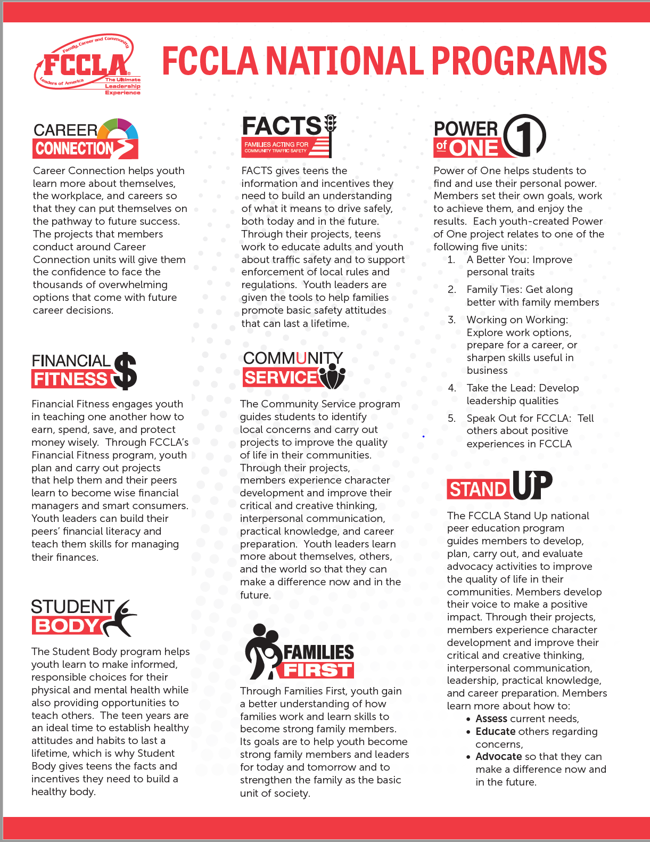

INTEGRATION OF FAMILY, CAREER AND COMMUNITY LEADERS OF AMERICA NATIONAL PROGRAMS AND PURPOSES INTO FAMILY AND CONSUMER SCIENCES EDUCATION CURRICULUM

EXAMPLE PLANNING CHART

CLASS TOPIC | CLASS PROJECT | FCCLA PURPOSE
Parent-teen relations | Teen-parent Talk Night  * Families First | Strengthen the function of the family.
Family Relationships--unit on building self-esteem | *Power of One units,  “A Better You,” or “Family Ties” | Provide opportunities for personal development and preparation for adult life.
Energy conservation unit | Plan and conduct a community recycling campaign.  * Community Service | Encourage democracy through cooperative action in the home and community.
Communication skills | *STAR Events Professional Presentation” or “Interpersonal Communications”. | Promote greater understanding between youth and adults.
Food preparation lab plans as part of foods and nutrition unit | Teach elementary students about nutritious snacks.  * Student Body | Provide opportunities for decision-making and for assuming responsibilities.
Introductory unit on “Balancing Work and Family” | Plan and carry out a panel presentation on the multiple roles of family members.  * Families First | Prepare for multiple roles of men and women in today’s society.
Career study in any FACSE class | Sponsor a career fair.  *Career Connection | Promote FACSE and related occupations.

*FCCLA national programs used as curriculum.

National programs are cross-walked with the FACSE National Standards. National programs also require the use of Washington’s learning standards, the Common Core Learning Standards and 21st Century Skills.
Integrating Family, Career and Community Leaders of America Chapters into the Family and Consumer Sciences Education Program

- Family, Career and Community Leaders of America should maintain its identify as an organization while it functions as a part of FACSE programs.
- Students, parents, and administrators must all see FCCLA as an integral part of the FACSE program.
- Each class should understand FCCLA, how it relates to the class, how it can add to classroom learning, and how it can offer opportunities for leadership development.
- The learning experiences are for everyone in class, members and non-members. However, only FCCLA members may hold chapter office; vote; be committee chairpersons; attend regional, state, and national meetings; hold district, state, and national office; participate in Power of One unit recognition, STAR events competition, and other national program opportunities beyond the classroom level; and attend programs of civic groups when FCCLA members are invited.
- If you wish to establish mini chapters in classes: To carry out some of the objectives of leadership development for all students, any class member may hold a class-level office regardless of whether he/she is a dues-paying member of FCCLA. Those class-level officers who are FCCLA members may function through FCCLA executive council, which would have voting privileges and decision-making executive power. The class-level officers do not have to be FCCLA members but a FCCLA member must represent the class chapter on the executive council.
- A plan for electing officers will need to be made depending upon the chapter and class structure selected.
- Chapters should provide opportunities for students not presently enrolled in FACSE classes, but who are eligible to become active members of the organization, to participate in chapter activities.
- Each chapter has to analyze its own situation and make a plan that best meets the needs of its school and FACSE program.

WHY ME?

Why are you an FCCLA adviser? Chances are, the role helps you meet professional goals and offers personal and professional satisfactions. As you “get psyched” for the year ahead, here’s a chance to remind yourself why you’re an adviser. Check all those that apply.

The key professional goals I achieve by advising a FCCLA chapter:
____facilitate youth leadership ____meet new people
____teach kids responsibility ____gain recognition locally
____prepare students for “real and beyond
life” ____have fun
____grow professionally ____find new challenges
____grow personally ____stay young
____develop a network of fellow ____build a strong family and
professionals consumer sciences
____improve teaching ____foster community
____travel awareness, support
____make a difference in young
peoples’ lives

My strongest qualities as an adviser:
____commitment ____promotional abilities
____honesty ____appreciation for teens
____openness ____letting kids take
____patience charge
____maturity ____friendliness
____humor ____curiosity
____discipline ____listening skills
____management skills ____motivational skills
____organizational skills ____consistency
____interpersonal communication ____persistence

Three areas I will work to improve this year:
1.

2.

3.

SECTION 3

NATIONAL PROGRAMS

POWER OF ONE

COMPETITIVE EVENTS

NATIONAL PROGRAMS

FCCLA empowers youth to address personal, work and societal issues through individual and chapter projects. Members’ involvement in any of the National Programs helps to expand their leadership potential and develop skills for life. National Programs include:

- CAREER CONNECTION
- COMMUNITY SERVICE
- FACTS (Families Acting for Community Traffic Safety)
- FAMILIES FIRST
- FINANCIAL FITNESS
- POWER OF ONE
- STAND UP
- STUDENT BODY

In addition to the National Programs, members and chapters can participate in the National Outreach Project. The National Outreach Project is a national community service activity that gives state delegations and their members the opportunity to make a united impact concerning a need. FCCLA wants its members to see and know first-hand that even a small effort made by many can have a huge and positive impact on others.

LINK TO NATIONAL PROGRAMS

For up-to-date information on National Programs, go to

https://fcclainc.org/engage/national-programs

POWER OF ONE

Power of One is a self-directed program for student/members to set goals, work to achieve them, and see results. Personal growth is what Power of One is all about.

Power of One is designed to give meaningful growth opportunities through application of knowledge and skills learned in class through projects of special interest to students.

Power of One offers students opportunities to:
☐ Examine issues in depth.
☐ Work alone at their own pace.
☐ Tackle personal projects.
☐ Explore special interests.
☐ Receive recognition for efforts.
☐ Learn to set goals and make decisions.
☐ Develop leadership skills.
☐ Extend class learning.

There are five units:

A Better You
Family Ties
Working on Working
Take the Lead
Speak Out for FCCLA

Each adviser should have at least one copy of the national resource publication Power of One, which can be reproduced for student use. It contains useful material for integrating into all classes and procedures for planning and evaluation. Copies are available at www.fcclainc.org.

Students completing five units should complete the appropriate on-line steps to receive state and/or national recognition. Advisers will need to encourage members and supply the forms!

COMPETITIVE EVENTS

FCCLA members can demonstrate family and consumer sciences skills, career skills and interpersonal skills through the following competitive events:

- STAR Events (Students Taking Action with Recognition)
These events are competitive events in which members are recognized for proficiency and achievement in chapter and individual projects, leadership skills, and career preparation.
- Skill Demonstration Events (held at National Fall Conference)
These events provide opportunities for members to demonstrate college and career-ready skills in Family and Consumer Sciences and related occupations. These competitions take place at National Cluster Meetings. Cluster Meeting information can be found on-line.
- FCCLA/Life Skills Knowledge Bowl
FCCLA/Life Skills Knowledge Bowl is a three-level, team competition that challenges students’ knowledge of all aspects of Family and Consumer Sciences:
- Personal Finance
- Consumer Rights and Responsibilities (to include Family, Career & Community Studies
- Technology (to include Fashion & Housing Design)
- Health & Safety (to include Food Science & Nutrition and Early Childhood & Human Development)
- Environment (to include Hospitality, Tourism & Recreation)
- FCCLA Knowledge

Levels 1 & 2 of this competition occur at National Fall Conference. Level 3 occurs at National Leadership Conference.

For up-to-date information on Competitive Events, go to

https://fcclainc.org/compete

SECTION 4

RESOURCES:
- “WHERE DO I FIND IT?” CHART
- PEOPLE WHO CAN HELP
- CHAPTER ACCOMPLISHMENT RIBBON APPLICATION

- PLANNING PROCESS
- PARTICIPATION CERTIFICATE
- APPRECIATION CERTIFICATE
- SAMPLE NAME CARD
- SAMPLE INTRODUCTORY BROCHURE
- STEP ONE ACTIVITY
- SAMPLE CODE OF CONDUCT
- CONSENT FOR EMERGENCY MEDICAL CARE

WHERE DO I FIND IT?

Listed below are the most commonly used resources. Be sure to check other resources available from these same sources.

Resource | Where to Look
Affiliation On-Line | https://fcclainc.org/join/chapter-affiliation
National Programs | https://fcclainc.org/engage/national-programs
Washington Chapter Accomplishment Ribbon Application | Washington Chapter Adviser Manual and state meeting registration packet
FCCLA Appreciation Certificate | Washington Chapter Adviser Manual
FCCLA Participation Certificate | Washington Chapter Adviser Manual
Master/Mentor Adviser Recognition Forms | https://fcclainc.org/lead/advisers/awards  or contact state adviser
National FCCLA Handbook to Ultimate Leadership | https://fccla.mybrightsites.com/
National Program guides | https://fccla.mybrightsites.com/
Adviser Newsletter/Fast Facts | E-mailed/Mailed to affiliated chapters
“Teen Times”  Member Magazine | Put into the FCCLA Portal
Emblematic Materials | https://fccla.mybrightsites.com/
FCCLA and FACSE National Standards Connection | https://www.pesb.wa.gov/preparation-programs/standards/endorsement-competencies/family-and-consumer-sciences-education/
21st Century Skills | http://www.k12.wa.us/CareerTechEd/TwentyFirstCenturySkills.aspx
WA-FCCLA Website | http://www.wa-fccla.org
Washington Weekly Newsletter | Contact Kathy Hahn to be added to contact list – kathyhahn@wa-fccla.org

PEOPLE WHO CAN HELP

Washington State FCCLA Adviser
Kathy Hahn
7412 143rd Ave NE
Lake Stevens, WA 98258
P-425-530-1907
kathyhahn@wa-fccla.org

Washington State FCCLA Executive Director
Mike Oechsner
PO Box 1440
Owasso, OK 74055
ExecutiveDirector@wa-fccla.org

Washington State FCCLA Finance Director
washington@ctsofinance.org

Washington State STAR Events Coordinator
Cathy White
cathyw16@outlook.com

Washington State Advisers to Advisers
Experienced FCCLA Advisers are available to help new/renewing advisers get started. The Advisers to Advisers will be announced in the Chapter Adviser Newsletter and on the member website.

Program Supervisor, Health and Human Services Pathway, OSPI
Michelle Spenser
Phone: 360-725-0417
michelle.spenser@k12.wa.us

Washington State FCCLA

Accomplishment Ribbons Application

Chapter Name: ________________________________________

Chapter Adviser(s): _____________________________________ Region #: _______

Due Date: Emailed February 1, 2022
Return to: Kathy Hahn, State Adviser kathyhahn@wa-fccla.org and
Mike Oechsner, Executive Director ExecutiveDirector@wa-fccla.org

Purpose: Chapters receive recognition for accomplishments during the current school year.
Criteria: One or more chapter members complete at least one activity in the category.
Limit: One ribbon is awarded for participation in each category.
Presentation: Ribbons will be awarded during the Regional Meeting at the SLC.

Category | Date of Participation
Advocacy – State or National (Capitol Leadership)
Career Connection
Community Service
Competitive Events
FACTS
Fall Regional Leadership Meeting
Families First
FCCLA Week
Financial Fitness
Go For The Red - Membership Campaign
Japanese Exchange
Power of One
Public Relations
“Say YES to FCS” Chapter Project - Washington State
STAND UP
Step 1
Student Body
Virtual Leadership Experience

FCCLA PLANNING PROCESS
Students and chapters need opportunities for self-evaluation. The same planning process may be used for group projects and to guide individuals in setting and reaching personal goals.  Using the planning process to work through meaningful projects can help members and chapters:  - discover more about themselves and what is important to them;  - accomplish a specific task;  - become more involved in family, school, and community life;  - broaden their understanding of their relationships with others;  - discover new opportunities; and  - prepare for adult roles.  Individual and chapter project planning follows the same steps.  Identify Concerns  Symbol: The circle represents a continuous flow of ideas and has no beginning or end. As a target, it symbolizes zeroing in on one idea around which your chapter would like to build a project.  Members begin by looking at themselves. What are their concerns about self, friends, family, school, and community? What are their special interests? To come up with a perfect goal, members write down answers to the above questions or brainstorm individual personal concerns.  Set a Goal  Symbol: The arrow stands for deciding which direction your chapter will take. It points toward the goal or end result.  Because students are unique, they have different goals and different potentials for achievement. The most satisfying projects are those with personal meaning. | Too many people make the mistake of setting impossible goals. Goals need to be realistic and attainable in a specified period of time.  Form a Plan  Symbol: The square represents the coming together of ideas—the who, what, where, when and how of your plan.  Decide what to do, when, where, and how to carry out the plan, and write down the steps to be followed. Available resources should be explored such as family members, other teachers, Teen Times, or employers.  Act  Symbol: The different squares in this symbol represent the activities to be carried out to meet your chapter goal. It represents acting on the plan.  Members and chapters put their plans into action.  Follow Up  Symbol: The broken squares suggest examining the project piece by piece. This symbol also represents a “window” through which to view and evaluate the plan.  On completing the project, members ask themselves if the desired results were achieved. If not, why not? Was the project worthy of the time and effort spent? Members should ask for help and suggestions from others as they work through their projects.

PLANNING PROCESS OVERVIEW

Identify Concerns

- Brainstorm concerns
- Evaluate listed concerns
- Narrow to one workable idea or concern

Set a Goal

- Get a clear mental picture of what you want to accomplish
- Write it down
- Evaluate it

Form a Plan

- Plan how to achieve goal
- Decide who, what, where, when, why and how

Act

- Carry out project

Follow up

Evaluate project

Thank people involved

Recognize participants

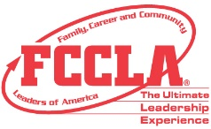
FCCLA Planning Process
Summary Page Template

IDENTIFY CONCERNS

SET A GOAL

FORM A PLAN (WHO, WHAT, WHEN, WHERE, HOW, COST, RESOURCES, AND EVALUATION)

ACT

FOLLOW UP

CERTIFICATE OF PARTICIPATION

Family, Career and Community
Leaders of America

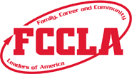

This is to recognize

whose participation in Family, Career and Community Leaders
of America exemplifies the goals and contributions of America’s youth.

President Administrator

Date Adviser

Certificate of Appreciation
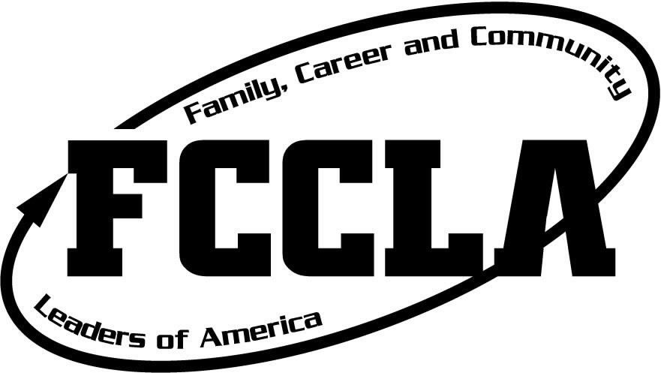

Name of Speaker

For

Inspiring us as the

Washington FCCLA Event Keynote Speaker

Year

____________________________________________________ ________________________________________________
Officer Title Officer Title

For meetings and gatherings, use a table name card that has a message on the back for your guests.

Name

Put a message on this side that you want your guests, advisory board members, etc. to remember about FCCLA (mission, purpose, other)

Family, Career and Community Leaders of America is…

Leadership in Your Family

Leadership in Your Career

Leadership in Your Community

---------------------------------------------------------------------------fold line---------------------------------------------------------------------

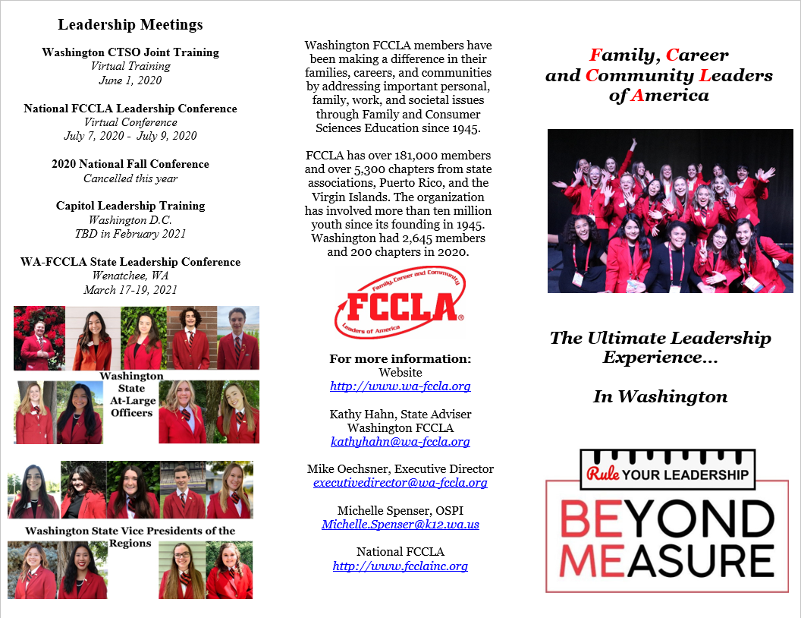
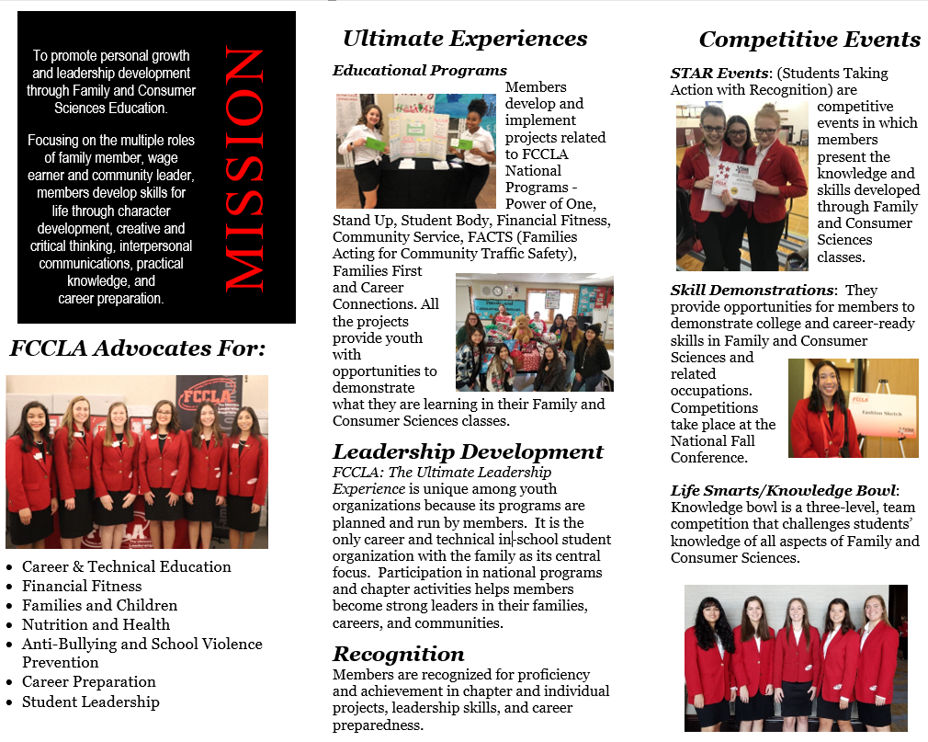
This two-sided brochure is available on Washington FCCLA website –

Teacher – Resources – Events and Conferences

https://wa-fccla.org/resources/

STEP ONE ACTIVITY

Step One introduces members to the organization. While primarily designed for students who have recently joined, it can be used as a refresher for other members to introduce them to information they may have missed in their first semester of involvement.

A member's first experience with the organization is crucial to the member’s continued involvement. This project is designed to give members quick exposure to the many opportunities the organization offers. Members want to feel a part of worthwhile activities and have fun at the same time. They want to develop friendships while pursuing interests related to their career and technical FACSE studies.

New advisers may want to refresh their memories about FCCLA. Assemble the FCCLA information before the students begin as members. Step One may require contacting your state adviser or sending for publications. You may want to ask additional questions about state and local activities.

To help students who may be discouraged by the type of research involved with Step One, try to think of creative ways to assist them. You might have them go on a scavenger hunt or post clues around the classroom. Encourage students to be creative in deciding how to research and present their findings.

Chapter officers and experienced members can play a key role by serving as evaluators. You might have a training session for these peer evaluators to check their knowledge.

Take advantage of this first activity to keep your students in FCCLA. Stress the many programs dealing with current teen concerns and help students see that through FCCLA they can address their concerns about society and families. Step One is also a great way to introduce the FCCLA planning process. Using the planning process teens can address issues such as:

• Teen nutrition and fitness.
• Family communication.
• Career advancement in FACSE related fields.
• Teen finances.
• Community service.
• Teen stress.
• Abusive environments for teens and children.
• Substance abuse.

The first semester of involvement is critical. In addition to letting members know what's available, help them identify their strongest interests and get them involved in a program right away. Work with your members to be sure the activities they undertake convey a strong, positive public image; leave favorable impressions about the career and technical FACSE program; and attract new members for next year.

For the next involvement activity, consider:

• National or state programs.
• National or state leadership conferences.
• Public relations activities.
• Membership campaigns.
• Committee assignments or chapter leadership roles.
• Community service.

If students plan to run for state office, STEP ONE is required.

Step One guidelines/activities may be found at https://fcclainc.org/sites/default/files/Step1Webquest.pdf

Here is a certificate for your members who complete Step One:

https://fcclainc.org/sites/default/files/Step1_Certificate.pdf

Washington

Family, Career and Community Leaders of America

Sample Code of Conduct

As a participant in an official FCCLA event, I understand that I represent my state, region, school, family, community, and chapter. Therefore, I will:

- Not consume, use, or have in my possession drugs, alcohol, or other illegal substances.
- Not break any civil/criminal law.
- Maintain professional behavior: as an FCCLA member I represent the organization, my school and myself in all my interactions with others.
- Inform adviser and/or chapter adult of my location at all times.
- Dress according to FCCLA Dress Code, as I reflect the image of FCCLA (no jeans, shorts or t-shirts, unless exceptions are made by state advisers i.e. conference t-shirt). This includes the closing session Friday.
- Meet with people, other than roommates, only in public places.
- Respect the dignity and privacy of roommates as well as all other event participants.
- Maintain professional relationships: recognizing that inappropriate physical contact with other members or students is not acceptable. Refrain from demonstrating public displays of affection.
- Respect hotel/convention center employees, guests, the community, and personal property.
- Participate in conference general sessions and workshops indicated on the program.
- Minimize noise in all public areas and hotel rooms, including TV’s and other forms of media, particularly after established curfew times.
- Remain in assigned room after curfew.
- Use all electronic devices, including cell phones, in an appropriate manner, including keeping them on privacy mode and not communicating during scheduled sessions and workshops.
- Give permission to be photographed and published.

________ Parents, initial here if your child may NOT be photographed and published.

I understand that failure to comply with the code of conduct may result in loss of privileges or other disciplinary action as determined by my local or state adviser.

(Date) (Student’s Signature)

I have read the Code of Conduct rules and regulations for Washington FCCLA. I also agree that the school/state staff have the right to send my son/daughter home from the activity at my (parent/guardian) expense, provided that he/she has violated the rules and/or his/her conduct has become a detriment.

(Date) (Parent/Guardian Signature)

Consent for Emergency Medical Care – Students
To be used for FCCLA State and National Meetings

Full name of participant (please print):______________________________________________
First Middle Last
Participant’s date of birth: .
Participant’s Medical History:
Please list any Allergies: ________________________________________________
Is medication needed for allergy: yes , no Name of medication:_________________________
Is medication needed for any other condition: yes____, no ____
If yes, what is the condition? _____________________Name of medication:____________________
Does participant wear contact lenses: yes , no Glasses: yes , no Identifying feature(s):______
Are all immunizations up to date? Yes____, no____; If no, please explain:__________________________
Past serious illness/injuries:

Medical conditions emergency care providers need to be aware of:

Insurance company: Group #: __________________________________
Family physician: Phone #: _________________________________
(Include copy of insurance card, front/back)

I authorize and instruct designated authorities to send the student (properly accompanied) to the most easily accessible doctor or hospital if the parent/guardian cannot be reached at the time of emergency and if treatment is urgent in the judgment of designated authorities. I understand that I (parent/guardian) will assume full responsibility for the payment of any services rendered. I expect that as parent/guardian I will be notified as soon as possible in the event of an emergency.
Full name of parent/guardian (please print):___________________________________________
First Middle Last
Parent/Guardian Signature: ______________________________________________________

Home address:_____________________________________________________________________
Street City State Zip
Home phone: ( ) .
*******************************************************************************************************************
I give my permission for the student named above to attend the _____ FCCLA State Leadership Mtg.
_____ FCCLA National Leadership Mtg.
Parents/Guardians: Please write your initials next to the meeting(s) your child will be attending.
Parent/ Guardian signatures must be notarized for attendance at the national meeting.

.
(School Official Signature) (School phone)

(Adviser Signature) (Cell Phone)

(Parent/Guardian Signature) (Home phone)

State of Washington County of _______________________________)ss.

Signed and sworn to before me on this ________ day of ________________, 20____, by __________________.

Printed Name:____________________________________
Notary Public in and for the state of Washington
My appointment expires: ___________________________

SECTION 5

GETTING STARTED FOR NEW ADVISERS:

YEAR AT A GLANCE

- PROGRAM OF WORK

- FCCLA PROGRAM OF WORK ACTIVITY QUALITY

FCCLA YEAR AT A GLANCE

Also there is calendar on WA-FCCLA Website: https://wa-fccla.org/resources/

SEPTEMBER  - Recruit members and gather information to affiliate online through the National Website.  - Determine class participation opportunities in Power of One  - Motivate interest and membership in each FACSE class  - Elect officers according to chosen chapter structure  - Contact state adviser to get on the e-mailing list | OCTOBER  - Collect dues and affiliate online-pay with credit card or PO https://fcclainc.org/join/chapter-affiliation  - Brainstorm chapter project and class activity ideas  - Develop chapter program of work (calendar)  - Plan to attend national Cluster meeting  - ATTEND REGIONAL LEADERSHIP MEETING | NOVEMBER  - Affiliate (money to Nationals) by November 1 to be eligible for State Incentive awards.  - Review guidelines for state and national programs  - Plan chapter and class activities  - Appoint committees
DECEMBER  - Carry out planned projects  - Read mailing about WA FCCLA State Leadership Conference  - Complete affiliation (needed to participate in regional star events) | JANUARY  - Carry out planned projects  - Complete forms to meet published deadlines  - Make sure dues payment was received at Nationals  - Register for STAR Events  - All competitors and volunteers MUST be affiliated to participate in REGIONAL and STATE STAR Events  - Regional STAR Events  - Fill out district request for National Leadership Conference travel | FEBRUARY  - Carry out planned projects  - FCCLA Week (in conjunction with Career and Technical Education Week)  - Any additional affiliation for SLC. (determines state voting delegates.)  - Mail award applications to the national FCCLA office and state office as designated  - Complete registration for WA FCCLA State Leadership Conference
MARCH  - Attend WA FCCLA State Leadership Conference  - Request funding to attend national meeting | APRIL  - Complete forms to attend National Leadership Conference | MAY  - Hold a recognition event/install officers

PROGRAM OF WORK

The Washington State FCCLA Annual Chapter Program of Work

A well-balanced program of work uses the FCCLA planning process to identify needs/concerns, set goals, plan, act/carry out and evaluate the work of the Washington Association of Family, Career and Community Leaders of America.

The Washington FCCLA Officer Team uses leadership, management and communication skills to plan, conduct and evaluate the state’s annual program of work.

The state’s annual program of work begins when the new state officers are elected at the FCCLA State Leadership Conference. The state officers gather information and ideas at the National Leadership Conference. That information is organized through state goals and objectives at the summer executive meeting. These goals are used to plan the sessions for fall regional meeting and the state leadership conference. The goals are also presented to chapters at the fall regional meeting to guide the development of each chapter’s program of work. At the spring regional meeting, chapters should be prepared to discuss their activities in relation to their program of work.

To help you plan your Chapter’s Program of Work, we have provided charts on pages 78- 79. Have your officers use the FCCLA Planning Process as they map out the types of activities that meet your overall Chapter Goals.

Format to Plan the FCCLA Annual Program of Work

1. FCCLA Needs and Concerns:

2. FCCLA Goals:

3. FCCLA Plan: Specific officer duty with input from all officers

The following table does not provide workspace. Please reproduce on an 8 ½ x 14” paper or classroom poster.
Program of Work Areas | Concern | Goal/ Objective | Activity | FACSE National Standard/s | FCCLA Purpose | 21st Century Skills | Chapter Member/s Responsible | How This Activity Will Be Completed | Measurable Data for Evaluation | Date  Finished
Membership Campaign
Meetings:
Chapter
Regional
State
WA State-at National
Ceremonies

Program of Work Areas | Concern | Goal/ Objective | Activity | FACSE National Standard/s | FCCLA Purpose | 21st Century Skills | Chapter Member/s Responsible | How This Activity Will Be Completed | Measurable Data for Evaluation | Date  Finished
Finances
(Chapter Resource Development)
Chapter Budget
Leadership
Activities

Competitive Events
Individual Projects/ Activities

Community Service Activities
State/ National Programs
Recognition Activities
Publicity

Program of Work Activity Quality

Officer/s Name ________________________________________________________

Program of Work Area and Specific Activity __________________________________

This activity demonstrates the following 21st Century Skills:
- Rigor
- Relevance
- Relationships

This activity demonstrates the following learning and innovation skills:
- Creativity & Innovation
- Critical Thinking & Problem Solving
- Communication & Collaboration

This project used the following Information, Media and Technology Skills:
- Information Literacy
- Media Literacy
- Communication Literacy
- Technology Literacy

This project/activity utilized the following Life and/or Career Skills:
- Flexibility & Adaptability
- Initiative & Self Direction
- Social & Cross-Cultural Skills
- Productivity & Accountability
- Leadership & Responsibility

Which purposes of FCCLA does this activity meet?

How does this activity increase awareness of FCCLA and Family and Consumer Sciences both to members and persons outside the organization?

How will this activity meet the needs/wants of male members (non-trad), and the large diversity of students within Washington public schools equitably?

