Washington FCCLA 2021-2022 State Calendar
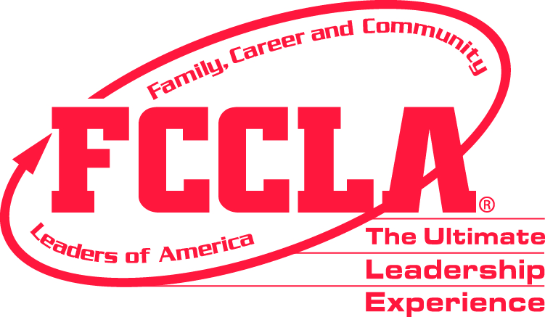

- Advise Career and Technical Education director, principal, and school district fiscal office of intent to attend one or more of the following events:
Regional Events
Region | Fall  Regional Mtg. | STAR Events | Contact Persons | Phone Number | E-mail
1
2
3 | 10/16/21 | 1/22/22 | Tricia Littlefield - Both | 253.891.5700 | tricia_littlefield@sumnersd.org
4 |  |  | Sarah Orton, Brianne Lutz, and Donna Abbey |  | ortons@issaquah.wednet.edu  lutzb@issaquah.wednet.edu  abbeyd@issaquah.wednet.edu
5 | 10/28/21 | 1/22/22 | Dawn Boyden - Both | 425.335.1515 | Dawn_Boyden@lkstevens.wednet.edu
6 | 10/9/21 | 1/12/22 | Cori Montgomery- Both | 509-663-8117 ext. 39500 | Montgomery.cori@wenatcheeschools.org
7 | 10/20/21 | 1/24/22 | Cheryl Uceny - Both | 855-380-8848 | Cheryl_uceny@ksd403.org
8 | 10/5/21 | 1/19/22 | Summer Henson – Fall Regional  Shanda Riehle– STAR Events | 509.346.2256  509-543-6763 ext. 5570 | shenson@royalsd.org  sriehle@psd1.org
9 | 10/21/21 | 1/20/22 | Courtney Schmidt-Fall Regional  Altaira Bogle – STAR Events | 509-284-3401 X-224  509-397-4368 | csears@tekoasd.org  altaira.bogle@csd300.org
10 | 10/20/21 | 1/25/22 | Stephanie Tetrick-Fall Regional  Barbara Hamilton-STAR Events | 509-738-6388  509-796-2701 | stetrick@kfschools.org  bhamilton@reardansd.net

- 2021 National Leadership Conference: June 25th – July 2nd, 2021 Nashville, TN ASB and/or school district should anticipate registration/tour money due by April 20, full payment required by June. Estimate $1,500 per participant.

- Capitol Leadership: November 4th & 5th – Washington DC

- National Fall Conference: November 5th – 7th – Washington DC

- State Leadership Conference: March 16th – 18th, Wenatchee Convention Center. ASB should anticipate a purchase order or check request. Estimate $275 per participant, $350 per adult (registration)

- August WA-ACTE Conference – August 8th – 11th, Davenport Grand Hotel, Spokane, WA
- August 10, 2021 – 9:15 am Workshop

- September Check for Chapter Adviser Mailing; Go online to www.fcclainc.org to affiliate your chapter & become familiar with services available to chapter advisers & members; Contact state adviser if not on state e-mail list or if you have changed schools or your e-mail has changed.

Plan for and attend your Regional Leadership Meeting

Check Washington Weekly newsletter (not receiving this newsletter contact – State Adviser – kathyhahn@wa-fccla.org ) and Washington State FCCLA Website for updated information to get your year started.

- October Plan for and attend your Regional Leadership Meeting.

Work with students on plans for National Program participation Career Connection, Community Service, FACTS, Families First, Financial Fitness, Stand Up, Power of One, and Student Body

Gather membership dues -- $20 per member, $20 per adviser, minimum 12 student members. Complete affiliation (paid) for all STAR Event participants and volunteers by December 31 to insure participation in Regional STAR Events. Affiliate online: www.fcclainc.org.

FCS Fall Conference - Virtual – October 23rd – 25th

- November State Officers must be affiliated by November 1.

- Chapters that have affiliated by this date are allowed one additional state meeting delegate and receive full benefits of membership from the national office.
- Attend a National Fall Conference: November 5th – 7th – Washington DC
- November 15th & 16th - tentatively, Winter Executive, WA-FCCLA At-Large State Officers and their advisers, Wenatchee, WA –

- December Encourage students to run for state office.
Election materials will be distributed to chapters via the State Vice Presidents in each Region. If you have not received election materials by December 31, contact Regional Vice President or State Adviser – kathyhahn@wa-fccla.org

Finish the affiliation process (including payment) at the National Affiliation website.

State leadership conference registration materials should have arrived for each affiliated chapter (by e-mail).

- January 2022 Happy New Year!

All AFFILIATED Chapters can register their AFFILIATED STAR EVENT PARTICIPANTS for Regional Competition. Culinary Arts and Baking and Pastry must affiliate and register through their Regional STAR Events registration for State Competition at this time.

Attend your Regional STAR Events competition. Students MUST be affiliated to compete or volunteer in Regional STAR Events. You will not be able to register unaffiliated students.

Begin completing award applications for state and national awards

If you have not received your State Leadership Conference packet by January 15, call the state adviser, or ExecutiveDirector@wa-fccla.

- January 28, 2022 - State Officers Civic Engagement Day – Olympia

- February 1 State Officer Applications Due - Email to State Adviser – kathyhahn@wa-fccla.org
Accomplishment Ribbon Requests – Emailed to State Adviser
Master Adviser and/or Adviser Mentor application due to state adviser
EMAIL the following to the State Adviser too - kathyhahn@wa-fccla.org
- FCCLA State Scholarship, Honorary Member nominations, Hall of Fame, and 5-Power of One Recognition

- February 8 State Leadership Conference Registration OPENS

- February 14th – 18th, 2022 - FCCLA Week

- February 18 State Leadership Conference Registration CLOSES. No changes, substitutions, or refunds after this date.

Request school district approval for travel to the FCCLA national leadership conference

- February 15 National Officer Candidates prepare materials and contact State Office for approval.

- Feb/March FACSE Board and Committee Meeting, Leavenworth, WA

- March 1 National Program Recognition applications for Career Connection, Community Service, FACTS, Families First, Financial Fitness, Stand Up, and Student Body to National FCCLA Office. Copies email to State Adviser and Executive Director.

- March 14-15 Spring Executive Council,
National Officer Candidates bring application materials for signatures.

- March 16-18 State Leadership Conference, Coast Conference Center, Wenatchee, WA

- March Prepare for National Leadership Conference. Clarify with administrators the number of potential participants and be prepared to make full payment by check, purchase order or credit card by specified dates.

- April National Leadership Conference Housing and WA State Travel Package Registration completed on- line. Information and due date will be available at State Leadership Conference.

National Leadership Conference Participant List and Travel Dates due to the State Office. Date TBD.

- April National Leadership Conference, STAR Events and tour registration completed in the National Leadership Conference Affiliation System.

- May TBD CTSO State Officer Leadership Meeting

- June Get ready for next year, a great summer, and perhaps the national leadership conference!

- June 29th – July 3rd, 2022 National Leadership Conference at San Diego, CA - ASB and/or school district should anticipate registration/tour money due by April 20, full payment required by June. Estimate $2,000 per participant.

Rest up and Enjoy the Summer!

Washington FCCLA web sites: http://www.wa-fccla.org http://www.k12.wa.us/CareerTechEd/pathways/HealthHumanSrv/Planning/Leadership.aspx
National FCCLA web site: http://www.fcclainc.org; WA-FACSE: http://www.wafacse.org

STATE STAFF E-Mail ADDRESSES:
State Adviser: Kathy Hahn, kathyhahn@wa-fccla.org
Executive Director: Mike Oechsner, ExecutiveDirector@wa-fccla.org

