Leadership Meetings

Washington CTSO Joint Training
Place TBD
May 22nd – 25th

National FCCLA Leadership Conference
San Diego, CA
June 25th – July 2nd

2021 National Fall Conference
Washington DC – November 5th – 7th

Capitol Leadership Training
Washington D.C.
November 4th and 5th

WA-FCCLA State Leadership Conference
Wenatchee, WA
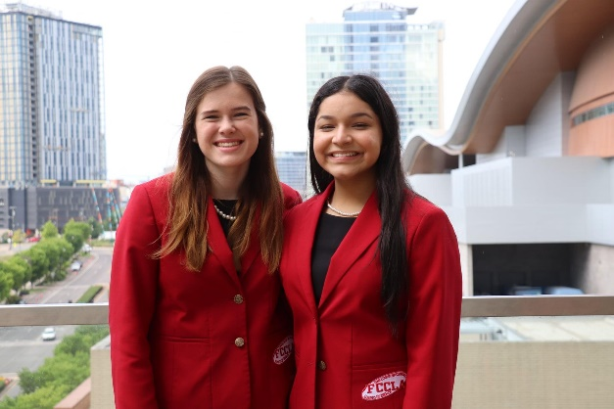
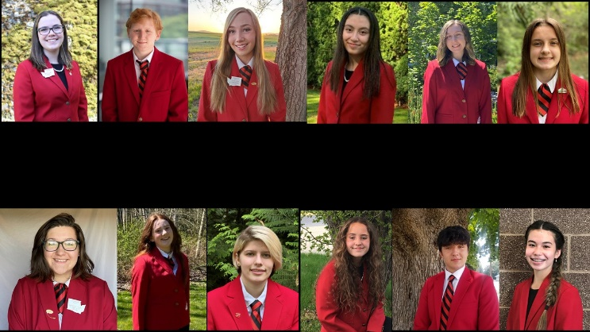
March 16th – 18th
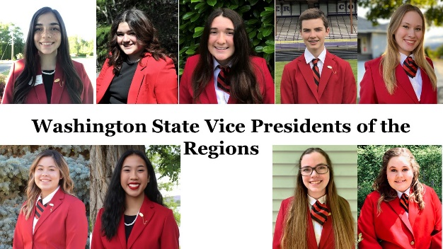

Washington FCCLA members have been making a difference in their families, careers, and communities by addressing important personal, family, work, and societal issues through Family and Consumer Sciences Education since 1945.

FCCLA has over 181,000 members and over 5,300 chapters from state associations, Puerto Rico, and the Virgin Islands. The organization has involved more than ten million youth since its founding in 1945. Washington had 2,645 members and 200 chapters in 2020.

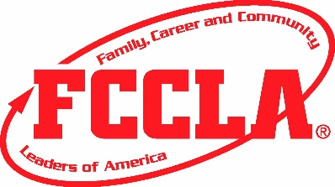

For more information:
Website
http://www.wa-fccla.org

Kathy Hahn, State Adviser
Washington FCCLA
kathyhahn@wa-fccla.org

Mike Oechsner, Executive Director
executivedirector@wa-fccla.org

Michelle Spenser, OSPI
Michelle.Spenser@k12.wa.us

National FCCLA
http://www.fcclainc.org

Family, Career
and Community Leaders
of America
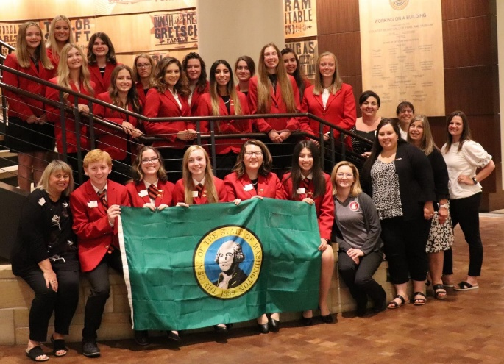

The Ultimate Leadership Experience…

In Washington

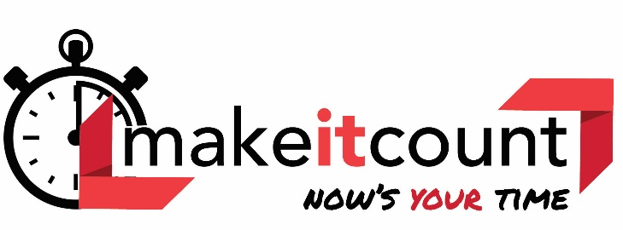

To promote personal growth and leadership development through Family and Consumer Sciences Education.  Focusing on the multiple roles  of family member, wage earner and community leader, members develop skills for  life through character development, creative and critical thinking, interpersonal communications, practical knowledge, and  career preparation. | MISSION

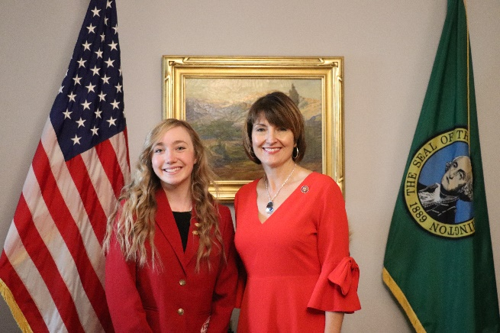
FCCLA Advocates For:
- Career & Technical Education
- Financial Fitness
- Families and Children
- Nutrition and Health
- Anti-Bullying and School Violence Prevention
- Career Preparation
- Student Leadership

Ultimate Experiences

Educational Programs
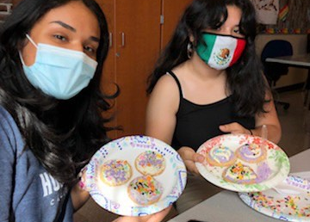
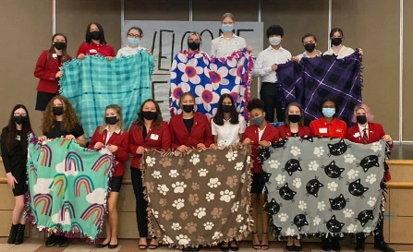
Members develop and implement projects related to FCCLA National Programs - Power of One, Stand Up, Student Body, Financial Fitness, Community Service, FACTS (Families Acting for Community Traffic Safety), Families First and Career Connections. All the projects provide youth with opportunities to demonstrate what they are learning in their Family and Consumer Sciences classes.

Leadership Development
FCCLA: The Ultimate Leadership Experience is unique among youth organizations because its programs are planned and run by members. It is the only career and technical in-school student organization with the family as its central focus. Participation in national programs and chapter activities helps members become strong leaders in their families, careers, and communities.

Recognition
Members are recognized for proficiency and achievement in chapter and individual projects, leadership skills, and career preparedness.

Competitive Events

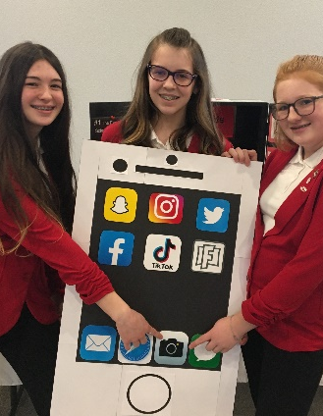
STAR Events: (Students Taking Action with Recognition) are competitive events in which members present the knowledge and skills developed through Family and Consumer Sciences classes.

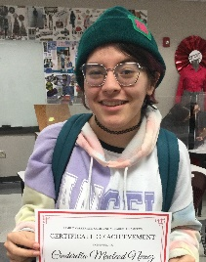
Skill Demonstrations: They provide opportunities for members to demonstrate college and career-ready skills in Family and Consumer Sciences and related occupations. Competitions take place at the National Fall Conference.

Life Smarts/Knowledge Bowl: Knowledge bowl is a three-level, team competition that challenges students’ knowledge of all aspects of Family and Consumer Sciences.
