n Washington Family, Career
and Community Leaders of America

This year’s theme:

TO: Chapter Advisers and Chapter Members

FROM: Kathy Hahn, State Adviser and Mike Oechsner, Executive Director

DATE: December 2021

RE: Election of State Officers (both at-large and vice presidents)

It is time to select the 2022-2023 state officers. Encourage qualified chapter members to apply for state officer positions. It is important students, parents and school administrators are aware of the duties and responsibilities of a state officer of Family, Career and Community Leaders of America and give their support to both the candidate AND the adviser.

Election of new officers will be held at state leadership conference, March 16th – 18th, 2022 in Wenatchee, WA. Each region will be electing one state officer (at large) and one state vice president. February 1st is the deadline for submitting ALL State Officer application forms electronically in PDF format and a copy of your chapter affiliation form to the State Adviser (kathyhahn@wa-fccla.org) and the officer responsible for FCCLA elections for 2022-2023 in your region (please refer to the list in this packet).

Before completing the State Officer Application –which has been updated and includes a new process of election, the adviser and candidate for office should review the attached qualifications list together and the adviser should use it as a basis for encouraging a candidate and signing a candidate’s application. Please do not run a candidate for a State Office if a change of the only adviser is anticipated for the following year (changing schools, retiring). It is important for the State Officer, the chapter adviser, the region, and for the state leadership to have clear, willing, consistent leadership in each school with a State Officer.

Advisers and officers work closely together throughout the year. Elected officers should have a designated time in his/her schedule to meet with the local adviser each day. Advisers AND State Officers are REQUIRED to attend Executive Council Meetings as assigned. If an officer does not attend a required meeting, they may be asked to relinquish their office.

Family, Career and Community Leaders of America is making a difference at home, at school, and in the community through outstanding student leaders. We hope that each chapter will urge one of their talented members to run for office. Your chapter must be affiliated by January 15, 2022, to have an officer candidate(s). A chapter may have one candidate for State Office (at-large) as well as one candidate for State Vice President.

“make it count” - “NOW’S YOUR TIME

Become a WA-FCCLA State Officer!

Two years and every day truly was about Making it Count! Washington FCCLA, you are my family. Running for office was one of the most empowering instances in my entire life. Who knew I'd come out of it with a team of people who I can honestly call my biggest supporters? Not only has becoming a state officer given me my best friends, but it has also given me a voice I didn't know I had.

I have traveled across the country, met with legislatures, and networked with leaders from all around the nation. All thanks to becoming a state officer. Through state office, you bond with your advisers and peers. I always saw the red blazers on stage, but never did I think I could be one. This is your sign. If you are holding this packet right now, and I encourage you to take the leap. You never know what kind of leadership journey state office could propel you on. I promise, your only regret will be not running sooner.

As I leave this year's state executive council, I encourage each of you to consider making this year count because Now is Your Time! FCCLA state office has forever impacted my life. I can't wait to see all that it has to offer for each of you!

You can contact me at alloyd@wa-fccla.org with any questions. Best of luck on your journey!

Alyssa Lloyd
Washington State President

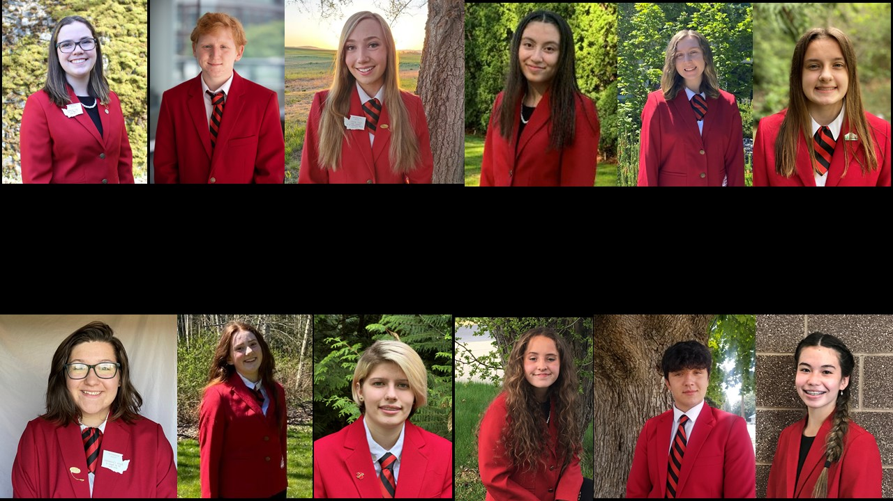

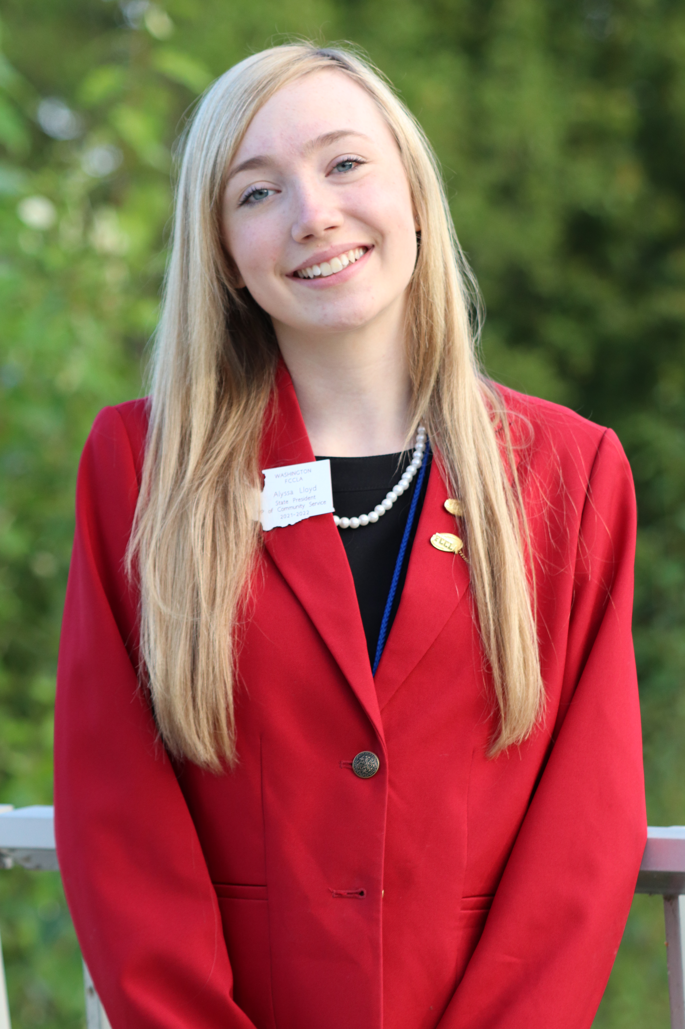

State Officer Information

Chapter Adviser - Officer Candidate Checklist

Before selecting state officer applicants--review the following criteria with each student candidate. This is for local discussion and decision-making and does not need to be turned in as part of the application packet.

Qualifications
Are you creative or imaginative? | Yes | No | Sometimes
Do you love to try new things and meet new people? | Yes | No | Sometimes
Do you promptly complete assigned jobs? | Yes | No | Sometimes
Are you a self-started leader? | Yes | No | Sometimes
Are you a team player? | Yes | No | Sometimes
When problems occur, do you look at the positive side of the situation? | Yes | No | Sometimes
Are you willing to commit your time and effort enthusiastically? | Yes | No | Sometimes
Are you willing to commit the time and effort necessary to assume a state leadership role? | Yes | No | Sometimes
Can you demonstrate confidence when speaking? | Yes | No | Sometimes
Can you motivate others? | Yes | No | Sometimes
Can you demonstrate knowledge of FCCLA such as the creed, purposes, and flower? | Yes | No | Sometimes
Are you willing to plan ahead and complete class and chapter responsibilities when you will miss school for state leadership participation? | Yes | No | Sometimes

Washington Family, Career
and Community Leaders of America
Washington FCCLA
PO Box 1440
Owasso, OK 74055

TO: Candidates for State Office

FROM: Kathy Hahn, State Adviser and Mike Oechsner, Executive Director

DATE: December 2021

RE: STATE OFFICER CANDIDATE INFORMATIONAL PACKET

Congratulations on your decision to run for State Office of Washington Family, Career and Community Leaders of America!

Election of new officers will be held at the state leadership conference. Each region will be electing one State Officer (at-large) and one State Vice President of a Region. These officers will comprise the state leadership executive team.

The attached materials include the general information on responsibilities and activities. Changes have been made. Please read this packet carefully. The names and addresses of advisers and the officers in charge of elections are enclosed.

ALL State Officer application materials along with recommendations must be received electronically in PDF format by February 1. Read all information very carefully and do not hesitate to ask questions. E-mail your completed application to the Washington State Adviser – Kathy Hahn (kathyhahn@wa-fccla.org) and the State Officer in charge of elections in your Region (see enclosure).

Your chapter must be affiliated by January 15, 2022 before an individual may run for state office. A chapter may have one candidate for State Officer (at-large) as well as one candidate for State Vice President of a Region.

The theme for the 2022 State Leadership Conference is: Make it Count …Now’s Your Time. We hope every state, chapter, and member will use the theme “Make it Count” to focus on how your leadership and life story has built FCCLA and how your leadership story is one that others will celebrate now and in the future.

Remember that you will be in front of the delegates during the opening session, regional meetings, and many of the other sessions. You need to be sure you are dressed according to the FCCLA Dress Code in order to appear capable of leadership responsibility.

A cover letter and resume may be sent to the chapters in your region before the state leadership conference; and the REQUIRED presentation board for the regional meeting are the ONLY campaign advertisements permitted. Buttons, banners, flyers, gifts, and similar items will be considered violations of the campaign policies. Officer candidates may have their presentation board at Regional STAR Events Recognition Session. Individuals found to be in violation of campaign policies will be disqualified.

We are excited that you are “Making it Count” in FCCLA by running for a State Officer Position!

POLICIES

I. OFFICERS

A. Elections

1. Nominations. Candidates for state office shall be nominated by the local chapters.

a. Each region shall elect one undesignated state officer and one state vice president.

b. Each chapter may submit no more than one candidate for each office. In the event there is a middle school candidate, who if elected would move to the high school, that candidate needs signed permission to run from the high school primary FCCLA adviser and school administrator.

c. Nominations from chapters shall be e-mailed to the state adviser and the officer in the region responsible for elections by a specified date.

2. Election procedures shall be determined by the state adviser, state staff, executive council, and advisory board. The candidate receiving the highest number of yes votes for the office shall be elected and shall assume office at the close of the annual state meeting.

3. The chair of the regional meeting (normally the State Vice President from that region) will vote only when a tie occurs during the election of the new state officers.

4. Qualifications of candidates:

a. Active membership in an affiliated chapter for one school year prior to assuming official duties.
b. Completion of one Family and Consumer Sciences education course.
- Completion of two Power of One projects in the current year and STEP One.

- A cumulative grade point average of 2.5 at the time of application.

General Information for WA-FCCLA State Officer Candidates

TRAVEL: Students and advisers are expected to travel together in groups as much as possible. Travel plans for each meeting/conference must be approved by a parent, adviser and/or regional adviser, and school administrator.

EXPENSES: Transportation expenses are reimbursable. Reimbursement is based on presenting itemized receipts or by mileage at the current state rate. Officers and advisers are encouraged to help keep the organization’s costs down. Most meals are purchased by WA-FCCLA, but officers and advisers should be prepared to purchase meals/snacks while traveling, not to exceed GSA meal allowance limits. Housing costs will be paid by the Washington Family, Career and Community Leaders of America.

Officer pins and guards will be presented following the State Leadership Conference or at May Executive Meeting. Name badges will be ordered following elections and distributed at the Executive Council meeting in May.

Prior to spending funds, prior approval from State Adviser and Executive Director is necessary to be reimbursed. If you should incur any other expenses as an officer during the year, keep an itemized record and ALL itemized receipts for submission to financial department.

STATE OFFICER UNIFORMS: Upon election, each officer will be expected to obtain the appropriate full uniform. The estimated total cost is $225.

The official blazer costs approximately $70. Some previous officers may be willing to sell their blazers at a reduced price. Blazers can be purchased through Blazer Depot or Twin Hill. Candidates should work with their chapter adviser to get a blazer ordered.

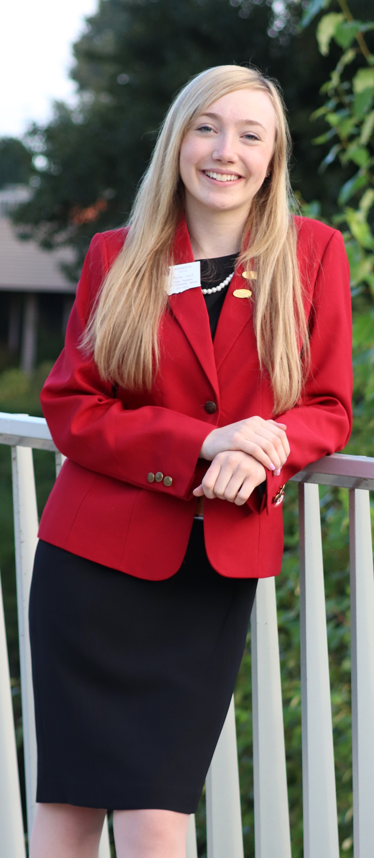
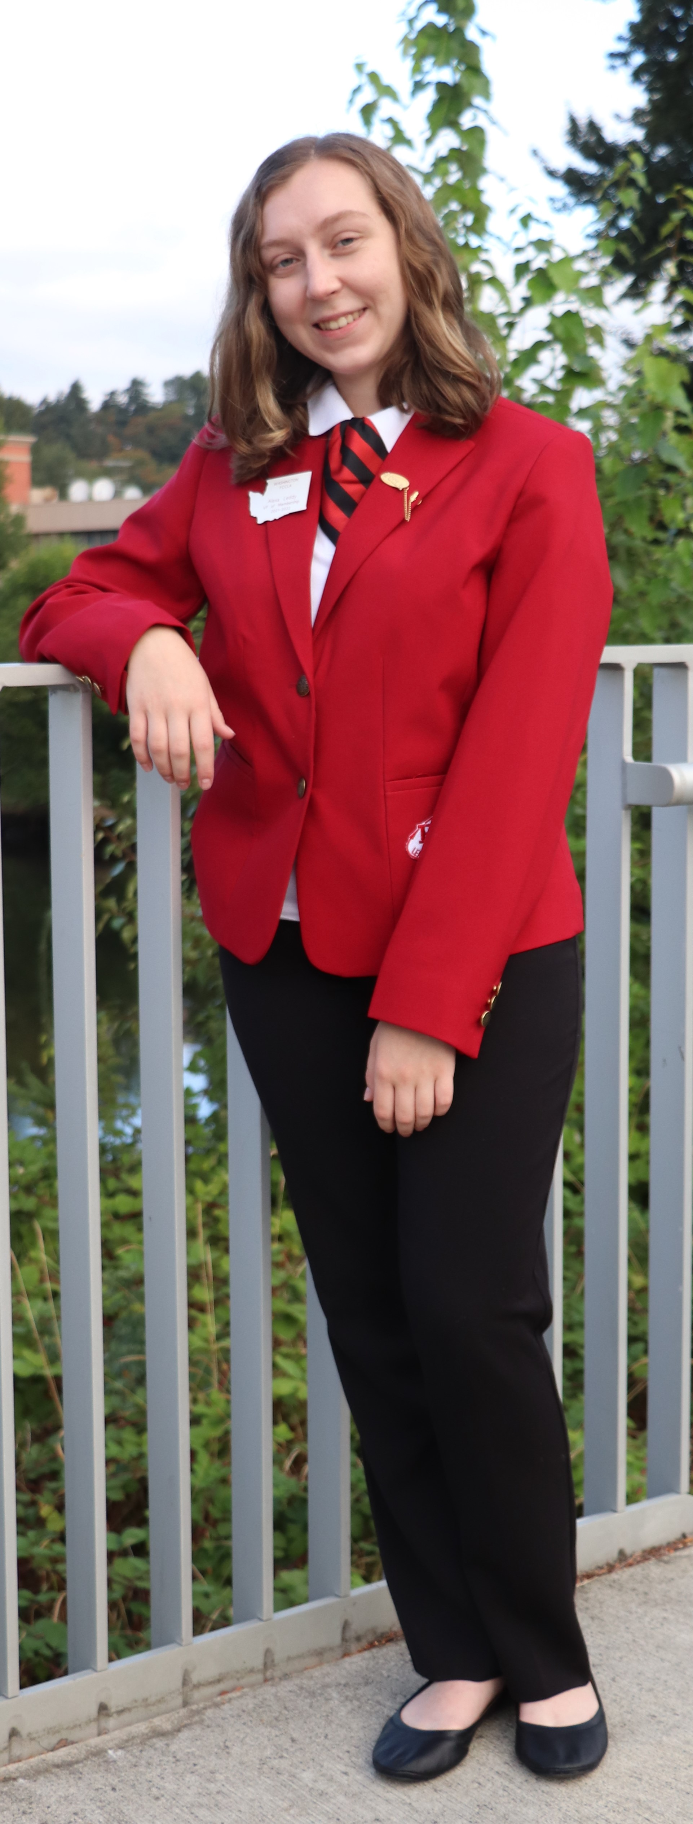
The state officer uniform will consist of:
Official Red Blazer
- Black sheath dress with skin-tone nylons
- Black skirt
- Black dress slacks with black socks
- Professional long sleeve white shirt with a pointed collar (oxford-style, with a button at the collar, suitable for a tie)
- FCCLA tie or FCCLA ascot
- Plain black dress shoes or pumps (no patent leather, suede, buckles, or bows)

*A document identifying where to purchase the specific shirt, dress, and pants that elected officers will be required to wear will be placed on the WA-FCCLA website in January and in Washington Weekly.

Questions: If you have any questions or problems with which your adviser and/or regional adviser cannot help you, please contact:

Kathy Hahn FCCLA State Adviser

kathyhahn@wa-fccla.org

How Do I Decide Which Office to Run For??

- There are two different types of offices
  - State Vice President of a Region or
  - State At-Large Officer where your specific position is determined at the State Leadership Conference by a collaborative process

Requirements | State Vice-President of Region | At-Large Candidate
Application | XXX | XXX  Additional Officer Position form to complete
Procedure to Run | XXX – See Application Packet | XXX – See Application Packet  - Interview additional  - Presentation to Executive Council to determine office
Meetings – | Check the informational packet for which meetings are required or recommended. | Check the informational packet for which meetings are required or recommended.
Fall Leadership Meeting | XXXX – in charge of this meeting | Attendance Required
Regional Spring STAR Events Meeting | Attendance Required | XXXX – in charge of this meeting
Regional Spring Meeting during State Conference | XXXX- in charge of this meeting | Attendance Required
State Leadership Conference | XXXX | XXXX
Duties | See information below | See information below

Duties of Officers - State Vice President of a Region

- The Vice Presidents of the Regions (10 total- one for each region) shall assume the responsibility for fall regional leadership meeting, elections, the spring regional leadership meeting, and submit a report of regional accomplishments at the state meeting.

Duties of Officers - At-Large Officer Positions

- The President shall preside over all business meetings of the organization and state executive council, appoint the chairperson and members of special committees not otherwise designated in the bylaws, promote state and/or national projects, be a member (ex officio) of all committees, be responsible for STAR Events regional evaluation and serve as a member of the Washington FCCLA Board of Directors.

- The Secretary shall keep the minutes of the state and executive council meetings and be responsible for STAR Events regional evaluation.

- The Vice President of Finance shall be responsible for communicating with the regions about finances. Shall submit the executive council needs for the proposed budget for the coming year, report to the delegates assembled in a state leadership conference the financial status of the organization, be responsible for STAR Events regional evaluation and shall serve as a member of the Washington FCCLA Board of Directors.

- The Vice President of Parliamentary Law shall see that order is maintained during meetings of the executive council. When amendments to the bylaws and other business of the organization are presented to the voting delegates, the Vice President of parliamentary law shall assist in conducting the meeting and be responsible for STAR Events regional evaluation. In the absence of the president, the Vice President of Parliamentary Law shall assume the responsibility of the president.

- The Vice President of Programs shall provide leadership in planning and implementing the organization’s state and national programs for individual development and peer education and be responsible for STAR Events regional evaluation.

- The Vice President of Recognition shall provide leadership in planning and implementing the organization’s recognition of member accomplishments and be responsible for STAR Events regional evaluation.

- The Vice President of Public Relations shall provide leadership in planning and implementing the organization’s public relations materials and programs and be responsible for STAR Events regional evaluation.

- The Vice President of Community Service shall provide leadership in planning and implementing the organization’s projects that make a difference in the school and community and be responsible for STAR Events regional evaluation.

- The Vice President of Membership shall provide leadership in planning and implementing programs for membership promotion and development and be responsible for STAR Events regional evaluation.

- The Vice President of Competitive Events shall provide leadership in planning and implementing the organization’s Competitive Events programs and be responsible for STAR Events regional evaluation.

Advisers to State Officers

Advisers to State Officers. The local advisers from each region serving on the state advisory board shall serve as regional advisers and assist their officers in fulfilling their duties

What this means:
As an adviser to a state officer, you too will serve in a role on the Washington State Advisory Board. You also agree to:
- Help your officer fulfill the duties of his/her office.
- Meet regularly with your state officer regarding progress toward regional and state goals and responsibilities.
- Travel with your state officer.
- Participate, as an active member, of the Washington FCCLA Advisory Board, and complete related committee assignments.
- Help plan and implement the Region’s Fall Conference (Adviser to State Vice-President) and Regional STAR Events (Adviser to At-Large Officer).
- Help plan and implement the State Leadership Conference.
- Provide guidance to FCCLA Advisers within the Region.
- Evaluate the commitment and work of your state officer.
- Complete special assignments based on your student’s office.
- When your officer is the only officer in your Region and they resign or must leave their office, you still hold a vital leadership role and are expected to attend any remaining Executive Council Meetings.

WA-FCCLA State Officer Candidate
Procedures Checklist

Prior to State Leadership Conference:

1. Read the ENTIRE state officer candidate packet

2. Qualifications: In order to run for office, candidates must:
- be an affiliated member from an affiliated chapter
- have a cumulative grade point average of 2.5 or higher at the time of application
- have completed a minimum of two Power of One Projects – during present school year
- have completed Step One
- have completed at least one Family and Consumer Sciences education course

3. Complete and e-mail application materials in PDF format to the State Adviser and State Officer in charge of elections in your region. This includes:
- Completed application
- Wallet-size photograph
- Copy of transcript
- Signed Code of Conduct Form
- Recommendations
- School administrator (required)
- Employer, youth group or community leader, or teacher
- Copy of your chapter affiliation form (your chapter must be affiliated by January 15th in order to have an officer candidate)

4. Write the meeting dates on your calendar. Officers must attend assigned required meetings/conferences or may be asked to relinquish their office.

5. Appropriate individuals have CAREFULLY READ, and signed, the Code of Conduct form.

6. At Large Candidates: Read the description of officer duties. Discuss those offices of interest with your adviser, parents/guardians, and school administrators. Complete the At-Large Officer Position Preference document which is included in application packet. This document should be email by February 1st with the rest of your application.

7. Prepare a presentation board no larger than 3' x 2' for the candidate fair at your regional spring meeting illustrating your qualifications. The display should be self-explanatory and may include posters, collages, a resume, or projects that demonstrate skill and competence. This board may include both FCCLA and other experience. (The presentation board could be on display at the Regional STAR Events held in the spring.) Display tables will be provided. If an easel is needed, please bring your own. At-Large candidate if elected, will bring presentation board to the selection meeting – Thursday morning.

8. For state leadership conference opening session, all officer candidates are to present a 20-second introductory commercial revolving around current state theme. Your name and school must be included. You may use a hand-carried prop. Remember the more you tie in the theme the more you will be remembered. No one may assist you with this presentation.

9. Prepare answers to ALL the following fact and opinion questions. You will answer one of the questions from each category during Spring Regional Meeting – Wednesday night:

Fact:
- What are the five components of the FCCLA Planning Process? Explain each step in the process and how it contributes to the overall success of your plan.

- Name one National Program. Describe a project you have worked on or could work on related to the National Program.

Opinion:
- Describe how an FCCLA activity has helped you become connected with your community or school.

- If you are talking to legislators, what would you say to them to encourage them to support Career and Technical Student Organizations.

10. Prepare a two-minute speech on this year’s theme.

11. As a State Officer you will be expected to know and explain facts about FCCLA. Review the following information to help you study for the FCCLA facts written test.

Basic Facts about FCCLA
- What the acronym FCCLA stands for
- Year FCCLA was founded
- Creed
- Mission
- Emblem
- Flower, Colors
- Motto
- Purposes
- What STAR stands for when referring to STAR Events
- Planning Process
- National Programs
- The official magazine of FCCLA
- Where the FCCLA National Headquarters is located
- Who the Washington FCCLA State Adviser is
- What the requirements are to become an FCCLA member?

Use the National Website as a resource for FCCLA Facts Written Test: www.fcclainc.org

12. OPTIONAL - If you want to create a resume and a one-page cover letter they could be sent to the chapters in your region after you have been approved as a candidate.

Washington Family, Career
and Community Leaders of America
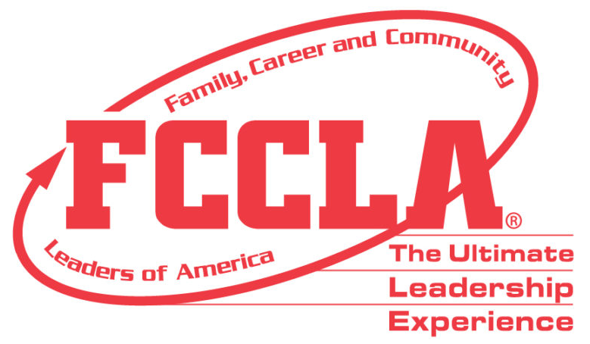

Election & Application Criteria Procedure

To ensure the high standard of our State Officer team, changes have been established to improve the election processes. The following are the requirements of each state officer candidate:

State Vice-President of a Region:
- Application to be filled out and emailed to State Adviser and State Officer in charge of elections in your region by February 1st
  - Wallet size Picture
  - Transcript
  - Signed Code of Conduct Form
  - Two letters of Recommendations
    - School Administrator (required)
    - Employer, youth group or community leader, or teacher
  - Printed Copy of your Chapter’s affiliation list
- Before state meeting
  - Create a presentation board 3’ x 2’ for the candidate fair and election process
  - Create a 20-second commercial revolving around current state theme
  - Prepare answers to fact and opinion questions
  - Prepare a 2-minute speech on this year’s theme for the election process
  - Study for your written test – Facts about FCCLA
- Written Test – will be given virtual in late February
- Wednesday, March 16th – there will be an officer candidate networking session in afternoon
- Opening Session – 20 second commercial
- Delegate Vote – at Spring Regional Meeting – March 16th – 8:30 – 9:00 pm
  - Present display board
  - 2-minute speech
  - Answer fact, opinion, and impromptu questions

State At-Large Officer
- Application to be filled out and emailed to State Adviser and State Officer in charge of elections in your region by February 1st
  - Wallet size Picture
  - Transcript
  - Signed Code of Conduct Form
  - Two letters of Recommendations
    - School Administrator (required)
    - Employer, youth group or community leader, or teacher
  - Printed Copy of your Chapter’s affiliation list

- Before state meeting
  - Create a presentation board 3’ x 2’ for the candidate fair and election process
  - Create a 20-second commercial revolving around current state theme
  - Prepare answers to fact and opinion questions
  - Prepare a 2-minute speech on this year’s theme for the election process
  - Study for you written test – Facts about FCCLA
- Written Test – will be given virtual in late February before you interview
- Interview – 5-10 minutes with panel of three-five adults, focusing on leadership qualifications and FCCLA experiences. The candidates will also present their 2-minute speech at the beginning of the interview process.
- Wednesday, March 16th – there will be an officer candidate networking session in afternoon
- Opening Session – 20 second commercial
- Delegate Vote – at Spring Regional Meeting – March 16th – 8:30 – 9:00 pm
  - Present display board
  - 2-minute speech
  - Answer fact, opinion, and impromptu questions
- Executive Council Vote, Thursday, March 17th – At-Large Officers will present their display board, might give their 2-minute speech, answer questions, and talk about the three officer positions they are interested in holding

During WA-FCCLA State Leadership Conference:
Wednesday, March 16, 2022

- During State Leadership Conference, all candidates will attend networking session. The time and place will be in the printed program. It is planned for 2:00 pm.

- State Leadership Conference opening session, all candidates will present their 20-second introductory commercial. Following the opening session, be prepared to participate in the candidate fair at your Spring Regional Meeting. Candidates will display their presentation boards and have the opportunity to respond to questions from the delegates as they informally review the displays and discuss qualifications.

- During the Spring Regional meeting, give your two-minute presentation on this year’s theme. You will be asked one fact and one opinion question from those listed above. You will also be asked one impromptu question (given to the regions by the state adviser). Impromptu questions are designed to test your ability to respond spontaneously and will further demonstrate your knowledge of FCCLA and your thoughts about leadership.

- Advisers to officer candidates must report to the STAR Events headquarters at 10:00 p.m. to pick up the letters to officer candidates. The letters will announce the results of the balloting process and should be opened in a private area with just the adviser and the officer candidate present.

Thursday, March 17, 2022
  - Newly elected state officers will meet with outgoing state officers for breakfast in the conference center. See conference program for time and room.

  - Newly elected state officers will meet in the morning to determine named officers’ positions. The time and place will be in the printed program. At-Large State Officers will need to bring their presentation board, 2-minute speech, and answers to the three offices you are interested in into this training. Lunch will be provided for the officers (you will need money to purchase a drink) during this training.

  - State Officers will work on their state Program of Work goals in the afternoon.

4. Advisers to state officers will meet for Adviser training. The time and place will be in the printed program. – The approximate time will be 1:00 pm – 3:00 pm.

Friday, March 18. 2022

- Installation Practice at 7:00 am - come prepared to wear:
Either a black woven straight skirt no shorter than 2” above the knee or black slacks and
Professional long sleeve white shirt with a pointed collar (oxford-style, with a button at the collar)

- State Officers and their Advisers – Informational meeting after State Leadership Conference – Time and place will be in the printed program. The approximate time will be 12:30-1:30 pm – if it is necessary to have to complete agenda items.

There will be a closed installation practice early on Friday morning for just the current and newly elected officers. Check your program for the time and location of this event.

Responsibilities/Obligations
WA-FCCLA State Officers

Completion of your application signals your willingness to commit your time to FCCLA and to uphold behavior expectations appropriate for a State Officer of FCCLA!

If elected, the candidate is REQUIRED to attend assigned meetings/conferences and leadership training noted on the State Officer Calendar (provided to candidates in this packet). Members who cannot commit to attending the meetings identified should reconsider whether this is a good time to run for a state office.

The elected officer should plan to have a designated time in his/her schedule to meet with the local adviser each school day. Individuals who do not attend the assigned required meetings/conferences may be asked to relinquish their office.

Your decision to be a candidate for a state office of Washington Family, Career and Community Leaders of America is an important one. The following should assist you in planning and scheduling to avoid conflict with other activities. Planning, implementing, and participating in meetings and conferences of FCCLA are essential duties of the WA-FCCLA State Officer. All meetings and conferences are **REQUIRED OF EACH OFFICER, AND THEIR ADVISER, unless otherwise stated. FCCLA is an integral part of FCS classes, and time in your classes is important for your personal success and to support your classmates and fellow FCCLA members. It will be necessary, however, for state officers to miss some days of class to participate in state leadership activities. In addition to the meetings/conferences listed, you may be asked to represent FCCLA at other meetings or activities held in your area. All arrangements for meetings and activities are made in cooperation with the officer, the FCCLA chapter adviser, parents, and the state adviser.
Washington Family, Career and Community Leaders of America
2022-2023 State Officer Calendar

MEETINGS and CONFERENCES | WHO | PURPOSE
**Informational State Officer meetings  State Leadership Conference  March 17, 2022 and March 18, 2022  Following closing session | State Officers  Advisers to State Officers | - Review uniform requirements  - CTSO Leadership Retreat  - National Leadership Conference Responsibilities
**WA State CTSO Leadership Retreat  Tentatively  May 22nd (Noon) – May 25th (Noon) | State Officers  Advisers to State Officers  ** Advisers are required to attend two of the days.  State Officers and their adviser will arrange state officer’s transportation home | - Develop leadership skills  - Plan for National Leadership Conf.  - State Program of Work  - Plan state projects and check uniforms  - Fall and Spring Regional Meeting - VP
**National Leadership Conference  June 27 - July 3, 2022 • San Diego, CA  San Diego, CA | State Officers  Advisers to State Officers  (State officer must travel with  local adviser) | - Prepare for annual activities  - State Office training  - Share and receive ideas/activities to bring back to WA and share
Capitol Leadership Conference  September/October 2022  Washington D. C. | (Recommended)  State Officers  Advisers to State Officers | - Leadership and Advocacy Training
**Regional Fall Planning Meeting Optional  September/October 2022  (Date set by region) | State Officers  Advisers to State Officers | - Meet with other officers and advisers  - Plan Fall Regional Meeting
**Fall Regional Leadership Meeting  October 2022 (Date set by region) | State Officers  Advisers to State Officers | - Implement Fall Regional Meeting
**November Executive Meeting  November 7th & 8th 2022  Wenatchee, WA | State Officers  Advisers to State Officers | - Plan: State Leadership Conference  - Regional STAR Events  - Review Program of Work goals
National Fall Conference, (Recommended)  November 11th – 13th  Columbus, OH | State Officers  Advisers to State Officers | - Leadership Training  - Competitive Events
**Regional STAR Events  January 2023  (Date set by region within state guidelines) | State Officers  Advisers to State Officers | - Conduct STAR Events
(Recommended)  Civic Advocacy Day  January 31st & February 1st, 2023 Olympia, WA | State Officers  Advisers to State Officers | - Meet with Legislators  - Advocate for FCS and CTSOs
**Spring Executive Council  March 13-14, 2023 - tentative  Wenatchee, WA | State Officers  Advisers to State Officers | - Finalize State Leadership Conference plans and evaluate year’s work
**State Leadership Conference  March 15-17, 2023 - tentative  Wenatchee, WA | State Officers  Advisers to State Officers | - Share year’s activities and present awards  - Conduct spring regional meeting and elections of state officers
2020-2021 - WA-FCCLA OFFICERS AND ADVISERS
RESPONSIBLE FOR FCCLA ELECTIONS
Region | Officer | Adviser
1 | No Officer | Kathy Hahn  Washington FCCLA State Adviser  425-530-1907  kathyhahn@wa-fccla.org
2 | No Officer | Kathy Hahn  Washington FCCLA State Adviser  425-530-1907  kathyhahn@wa-fccla.org
3  Vice President | Hailey Littlefield  hlittlefield@wa-fccla.org | Tricia Littlefield  Bonney Lake High School  253.891.5700  tricia_littlefield@sumnersd.org
4 | No Officer | Kathy Hahn  Washington FCCLA State Adviser  425-530-1907  kathyhahn@wa-fccla.org
5  Vice President | Molly Rose Bates  mrbates@wa-fccla.org | Dawn Boyden  Lake Stevens High School  425.335.1515  Dawn_Boyden@lkstevens.wednet.edu
6  Vice President | Alexa Leddy  aleddy@wa-fccla.org | Cori Montgomery  Wenatchee High School  509-663-8117 ext. 39500  montgomery.cori@wenatcheeschools.org
7  Vice President | Gilena Provaznik  gprovaznik@wa-fccla.org | Cheryl Uceny  Kittitas Jr./Sr. High School  855-380-8848 509-968-3370 (fax)  Cheryl_uceny@ksd403.org
8  Vice President | Brynn Christensen  bchristensen@wa-fccla.org | Summer Henson  Royal High School  509.346.2256  shenson@royalsd.org
9  Vice President | Julian Meredith  jmeredith@wa-fccla.org | Courtney Schmidt  Tekoa High School  509-284-3401-X224  cschmidt@tekoasd.org
10  Vice President | Robyn Wright  robynwright@wa-fccla.org | Stephanie Tetrick  Kettle Falls High School  509-738-6388 ext.414 509-738-2670 (fax)  stetrick@kfschools.org

