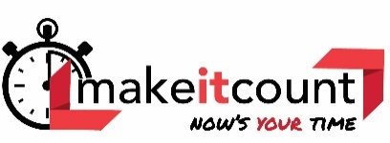

WASHINGTON STATE FCCLA
the HERO in
us all
2021-2022 PROGRAM OF WORK

Washington FCCLA State Officers have developed their Program of Work for the year. This year our Executive Council will be focusing on publicity and increasing membership.

Our State VP of Regions Goal is to focus on increasing membership in our regions by promoting FCCLA on social media, chapters in our region, and our friends.

They plan to accomplish their goal in a variety of ways. Here are some examples of their Regional action plans:

Posters to promote FCCLA in your schools
Social Media – Instagram account for all Regions
Press Releases for chapters to use for social media
Monthly posts about activities happening and due dates

Our State Goal is to focus on communication with all members in Washington State as we transition into an in-person format within our specific offices.

Another goal is to help guide and keep informed Regions 1,2,and 4 who do not have state officers.

Our At Large Officers intend to accomplish this goal by communicating using a variety of methods and to work with advisers in the regions with no officers. Here are some examples of their State-Wide action plans:

Membership Challenge: Your Time to Shine
National Program Videos
Follow me Friday – Social Media Challenges
Recognition: Challenging Chapters to get Involved!
Parliamentary Law Procedure Videos
Creating an interactive workshop, “Competitive Events”
Monthly Membership Newsletter – Red Report
Community Service – Cancer Awareness/Education

AFFILIATION
November 1 is our Washington Early Affiliation Date. Early affiliation allows you to bring another member to State Leadership Conference in March.

- You will also have unlimited access to the Competitive Events Guide as an affiliated chapter. Those chapters that have not affiliated by November 1 will not have access to the National Competitive Events Guide. AFFILIATE EARLY!

