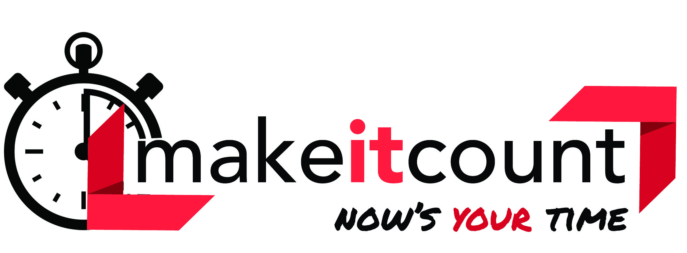
WASHINGTON FCCLA

2021-2022 REGIONAL INFORMATION SHEET

(Regions are composed of counties and portions of counties as described below)

REGION 1: Kitsap, Clallam, Jefferson & Mason  Contact Adviser: Vacant  REGION 2: Grays Harbor, Pacific, Lewis,  Wahkiakum, Cowlitz, Clark, Skamania  Contact Adviser: Vacant  REGION 3: Pierce, Thurston  Contact Adviser: Tricia Littlefield  Bonney Lake High School  10920 199th Ave Ct East, Bonney Lake, WA 98391  (253-891-5700)- Classroom  tricia_littlefield@sumnersd.org  State Vice President of Region 3: Hailey Littlefield  State Vice President of Competitive Events & Co-Vice President of Programs: Paige Littlefield  Adviser: Tricia Littlefield, Bonney Lake HS  REGION 4: King  Contact Adviser: Vacant  REGION 5: Whatcom, Skagit, Snohomish, Island,  San Juan  Contact Adviser: Dawn Boyden  Lake Stevens High School  2908 113th Ave NE  Lake Stevens, WA 98258  425.335.1515  Dawn_Boyden@lkstevens.wednet.edu  State Vice President of Region 5: Molly Rose Bates  REGION 6: Okanogan, Douglas, Chelan, Ferry, Grand Coulee Dam, Republic, Curlew & Quincy SD  Contact Adviser: Cori Montgomery  Wenatchee High School  1101 Millerdale Ave, Wenatchee, WA 98801  509-663-8117 ext. 500  montgomery.cori@wenatcheeschools.org  Acting State Vice President of Region 6: Alexa Leddy  State Vice President of Membership: Alexa Leddy  ***FCCLA State Adviser: Kathy Hahn  kathyhahn@wa-fccla.org  ** Contact me to receive the Washington Weekly newsletter!  Visit our WA FCCLA Website at wa-fccla.org | REGION 7: Kittitas, Yakima, Klickitat  Contact Adviser: Cheryl Uceny  Kittitas Secondary School  P.O. Box 599, Kittitas, WA 98934  855-380-8848 509-899-2394 (cell)  Cheryl_uceny@ksd403.org  State Vice President of Region 7: Gilena Provaznik  State VP of Public Relations and Co- VP of Programs: Lizbeth Villegas  Adviser: Cheryl Uceny, Kittitas Secondary  REGION 8: Benton, Franklin, Grant, Columbia-  Burbank & Othello School Districts  Contact Adviser: Summer Henson  Royal High School  955 Ahlers Road  Royal City, WA 99357  509.346.2256  shenson@royalsd.org  State Vice President of Region 8: Brynn Christensen  State VP of Recognition & VP of Parliamentary Law: Matthew Bruce  Adviser: Shanda Riehle, Chiawana HS  REGION 9: Adams, Whitman, Asotin, Garfield,  Columbia, Walla Walla  Contact Adviser: Courtney Schmidt  Tekoa High School  513 Henkle St  Tekoa, WA 99033  509-284-3401-X224  csears@tekoasd.org  State Vice President of Region 9: Julian Meredith  State Secretary & State VP of Finance: Katherine Tate  Adviser: Altaira Bogle, Colfax HS  REGION 10: Stevens, Pend Oreille, Spokane, Lincoln  Contact Adviser: Stephanie Tetrick  Kettle Falls HS  PO Box 458, Kettle Falls, WA 99141  509-738-6388 ext 414  stetrick@kfschools.org  State Vice President of Region 10: Robyn Wright  State President and VP of Community Service: Alyssa Lloyd  Adviser: Barbara Hamilton, Reardan HS

