WA-ACTE FACSE PRESENTATION
INTRO AND PROGRAM OF WORK

** I will welcome and give quick intro at the
beginning of session

Slide 1 Alyssa:
Good morning. Welcome you our workshop – Make it Count – Now’s your time with FCCLA. My name is Alyssa Lloyd and I am the 2021-2022 Washington State President for Family, Career and Community Leaders of America.

I would like to make a few more introductions this morning.

Slide 2 Alyssa:

First, it is my pleasure to introduce
Kathy Hahn, Washington FCCLA State Adviser.

And Michelle Spenser,
Career and Technical Education Family and Consumer Science Education Program Supervisor from the Office of Superintendent of Public Instruction. Mrs. Spenser serves on the State FCCLA Board of Directors

In addition, I would like to introduce:
Paige Littlefield, State Vice President of Competitive Events and Co-VP of Programs

Slide 3: Paige
We also have some of our State Advisory Board Members here today. If you are in-person or virtual will you introduce yourself and let everyone know what region you represent?

Thank you

We are here today to report on the 2021 Hybrid National Leadership Conference, to inform you about our new National and State Theme, summarize our State Officer Program of Work for 2021-2022, share new information, and answer questions

Slide 4 :Paige
The 2021-2022 National Theme is “Make it Count”.
Life is short, time goes fast, and days are limited. It’s up to you to choose how you can make every moment meaningful. Use the 2021-2022 annual theme to challenge yourself to set goals, embrace experiences, learn new skills, take ownership, and live every day with intention because you only get one chance to “Make it Count!”

In June, our Executive Council added a tagline to the National Logo. I’m happy to announce the Washington State 2021-2022 Theme is “Make it Count” – Now’s Your Time.

We have included a handout, giving you the names of the Adult Regional contact and the names of the State Officers in your region. In addition, you will see our state adviser- Kathy Hahn’s information on that sheet as well.

Slide 5: Alyssa
Your Contact person From Region 1 is
We are looking for an adviser who will be the contact person for the region. If you are in Region 1 please contact state adviser – Kathy Hahn and let her know you are interested in taking this leadership role to help provide opportunities for the students in your region.

Your Contact person From Region 2 are
We are looking for an adviser who will be the contact person for the region. If you are in Region 2 please contact state adviser – Kathy Hahn and let her know you are interested in taking this leadership role to help provide opportunities for the students in your region.

Slide 6: Alyssa
Your State Officers From Region 3 are
Hailey Littlefield, State Vice President of Region 3, and her adviser Tricia Littlefield – Bonney Lake High School
and
Paige Littlefield, State Vice President of Competitive Events and Co-Vice President of Programs, and her adviser Tricia Littlefield – Bonney Lake High School.

Slide 7: Alyssa
Your Contact person From Region 4 are
We are looking for an adviser who will be the contact person for the region. If you are in Region 4 please contact state adviser – Kathy Hahn and let her know you are interested in taking this leadership role to help provide opportunities for the students in your region.

Slide 8: Alyssa

Your State Officer From Region 5 are
Molly Rose Bates, State Vice President of Region 5 from Lake Stevens High School

And her adviser is Dawn Boyden

Slide 9: Alyssa

Your State Officer From Region 6 are
Alexa Leddy, State Vice President of Membership
And her adviser is Cori Montgomery – Wenatchee High School
Alexa is also the acting State Vice President of Region 6

Slide 10: Paige

Your State Officers From Region 7 are
Gilena Provaznik, State Vice President of Region 7

And
Lizbeth Villegas, State Vice President of Public Relations and Co-Vice President of Programs
Their adviser is Cheryl Uceny – Kittitas Secondary School

Slide 11: Paige

Your State Officers From Region 8 are
Brynn Christensen, State Vice President of Region 8 from Royal High School, her adviser is Summer Henson and

Matthew Bruce, State Vice President of Recognition and State Vice President of Parliamentary Law
His adviser is Shanda Riehle - Chiawana High School

Slide 12: Paige
Your State Officers From Region 9 is

Julian Meredith – State Vice President of Region 9 from Tekoa High School and his adviser is Courtney Schmidt

And

Katherine Tate, State Secretary and State Vice President of Finance
Her adviser is Altaira Bogle - Colfax High School

Slide 13: Paige
And your State Officers From Region 10 are

Robyn Wright State Vice President of Region 10
Robyn’s adviser is Stephanie Tetrick – Kettle Falls HS

and
Alyssa Lloyd – State President and State VP of Community Service
Alyssa’s adviser is Barbara Hamilton – Reardan High School

We hope that if you have questions you will feel free to give your Regional Contacts a call.

At this time we have a PPT Presentation summarizing our 2021 Hybrid National Leadership Conference.

(Go to National Leadership Conference Script)

Paige: Slide 15
This year our Executive Council set their Program of Work goals in May during our weekly zoom meetings. As a group, we identified a Regional Program of Work Goal and a State Program of Work goal. The State Officer team then came up with activities to help achieve these Program of Work Goals.

There is a handout with this information available to you – It will give you an idea of the activities your chapter has to look forward to from our state leadership team. Check out our state website wa-fccla.org at the beginning of September to get details on these activities and through the Washington Weekly.

Paige: Slide 16
Our State Vice Presidents of the Regions Goal is to:
Focus on increasing membership in our regions by promoting FCCLA on social media (Regional Instagram), chapters in our region, and our friends.

Your State Vice Presidents of your Region will be contacting you about the projects they have planned to achieve this goal.

SLIDE 16 ALYSSA:

Our State Goal identified by the named officers is to:
Focus on communication with all the members in Washington State as we transition into an in-person format within our specific offices.

Another goal is to help guide and keep informed the regions (Region 1, 2, and 4 ) without assigned officers.

The Named Officers also have planned some creative projects to achieve this goal and are excited to begin!!

Now some Updates from our State Adviser – Kathy Hahn

Kathy - SLIDE 17: Membership Resources
Nationals has sent out their membership kits in the spring – Make sure you check out all that is included in this mailing.

- Go for the Red
- Communication Calendar
- Theme Logo

** Today – Membership Madness Toolkit – Check it out- there are prizes and resources to win – To apply visit the Survey/Applications tab in the FCCLA portal.

Kathy SLIDE 18:

Chapter affiliation is an important step in joining FCCLA. To provide support and assistance post-pandemic, the Executive Committee of the FCCLA National Board of Directors approved to offer two temporary membership package options for the 2021-2022 school year.

Affiliation options for Washington State:

- 1. Regular Affiliation – Minimum of 12 members - $9.00 National Dues each, $11.00 State Dues each

- 2. Up to 25 Chapter Package – See benefits below - $395.00 – Nationals, $275 – State – for a total of $670.00
- 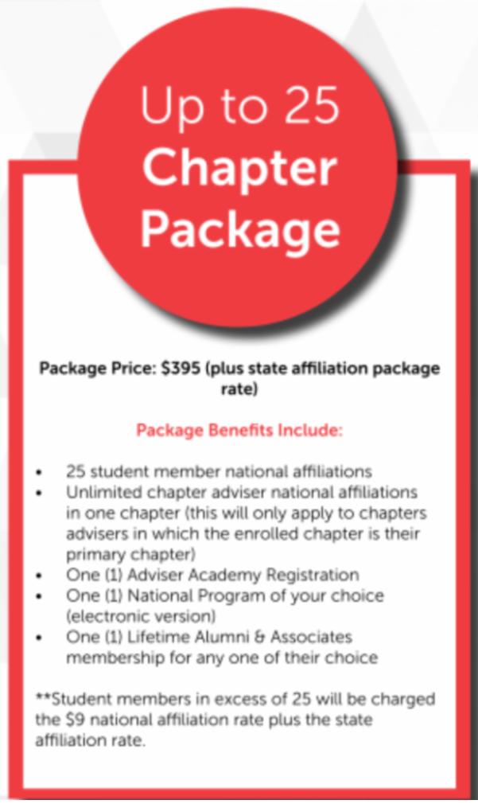

- 3. Unlimited Membership per Chapter – NOT a school district - - $775 National and $900 State for total $1675

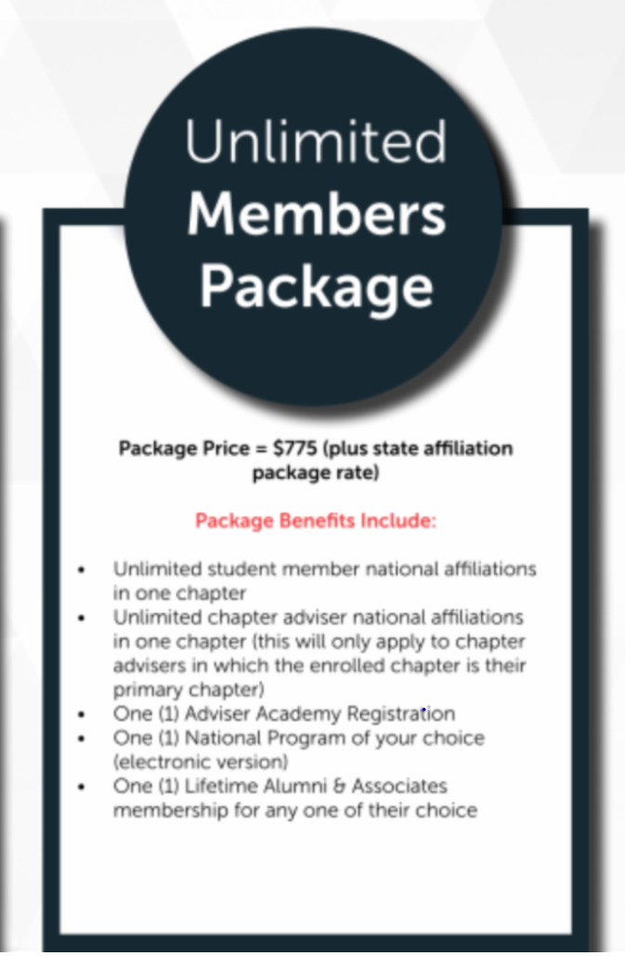

- 4. 100% Middle School Affiliation - $250 National, $300 State –for a total of $550 Contact me if these is something you are interested in - It is for 9th grade and below – Before an invoice is generated I will need to go in and change your affiliate type to MS Unlimited Affiliation.

The temporary membership packages are intended to be part of the economic recovery support for Family and Consumer Sciences educators and students as we look to further grow and strengthen our organization. These packages are available until November 1, 2021.

Kathy SLIDE 19:

New Chapter Adviser Handbook

This is a new updated resource for advisers – To be able to download this resource go to National FCCLA website – Join - Chapter Affiliation.

Kathy SLIDE 20:

FCCLA Calendar
Fall Regional Meetings at the present time are a little up in the air! The officer team and their advisers will be meeting in September to finalize dates. Keep in contact with your region’s contacts to know when the meeting are set. Also the Washington Weekly will always have the most up-to-dates on activities and meetings!

Kathy SLIDE 21:

Washington Weekly

Talk about it………

Kathy SLIDE 22:

Questions????

