Washington FCCLA Virtual State Officer Election PLAN
2020-2021 Election Guidelines

- This year, the State Officer election will happen virtually. Each candidate will be provided with an online webpage where their information will be showcased to voting delegates and other members. As you prepare materials, do so as if you were to show or share the information in person.

- You will receive a link to Wufoo – where you will upload the following documents/videos. Use the link, leadable.info/WAFCCLACandidateInfoForm and submit the following by 11:59 pm Pacific Time on Monday, April 13, 2020.

  - Information about you: Name, School, Grade in School, Region, Office you are running for – State Vice-President or At-Large Officer
  - Upload images of your board – pictures or PDF
  - Pre-recorded video of 20 second commercial – this will be included in Opening Session. This video MUST be recorded in a horizontal format (think YouTube, not Instagram Story) and uploaded online so you can share a link on the form (Google Drive, Dropbox, etc.) so it can be downloaded. The video cannot exceed 20 seconds.
  - Pre-recorded 2-minute speech on this year’s theme – Submit a link to your speech! This video MUST be recorded in a horizontal format (think YouTube, not Instagram Story) and uploaded online so you can share a link on the form (Google Drive, Dropbox, etc.) so it can be downloaded. This video cannot exceed 2 minutes.
  - Head Shot in FCCLA Dress Code with non-distracting background

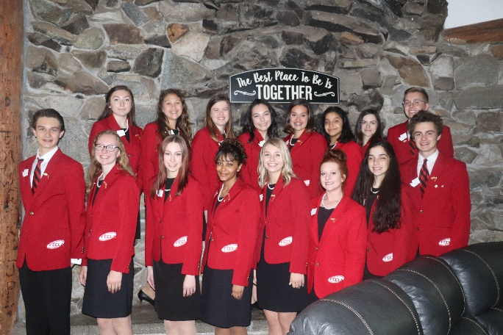
- During Regional Meeting – in zoom setting will answer questions (Fact, Opinion, and Impromptu Questions)
- Those question were given in the officer packet – will only answer one of each – state adviser will choose the questions
- Region 1,2,3,4,5 – April 27th – Time TBD
- Region 6,7,8,9,10 – April 28th – Time TBD

- Voting will take place on April 29th 12 pm-3:00 pm – Adviser will receive a link for their voting delegate to vote. One link for each voting delegate they have

- Letters will be sent to all officer candidates by 5:00 pm on April 29th on whether they are an officer or not

- Official Announcement in Award Session – May 5th (for now)

- Announced to public next day – on Social Media

To be completed later:

- Interviews with At-Large Officers – this could be zoom meeting in May

- Networking of Officers - through zoom - possibility

- CTSO Officer Training - May 31st – June 3rd if we have this training it would include:
- FCCLA Fact Test
- Position Selection Process
- If training postpone - it will be determined - when we will determine the At-Large Officers positions - We will try to meet for a day??

- CTSO Officer Training could be August 23, 24, 25, 26

Thanks so much!!

Additional Tips when Recording

Remember these key pieces:
- If you are using a phone to record, record your video horizontally
(think YouTube not Instagram Stories).
- Frame your video with some space above your head and you
centered in the frame. (like a news reporter)
- Make sure that there are no harsh shadows on or behind you. Use a
lamp or other light from behind the camera to help make sure you can be seen clearly.
- Be in a quiet environment when you film. Ask family members to be
quiet and not interrupt, move away from loud or echoey areas of your home (windows close to busy roads, loud machines and fans, etc.)
- FCCLA Dress Code – commercial can have props
- Find a simple background that isn’t messy or distracting.

When Done with Video

- Re-watch it to ensure that the lighting, sound, and feel of the video is good!
- Once a video is complete, upload it!
- When you have completed your entire Wufoo officer candidate uploading, please notify myself-Mrs. Hahn ( kathyhahn@wa-fccla.org) so I know it has been completed!

